****

**The TARGET Antibiotics Toolkit**

**Guide to Resources**

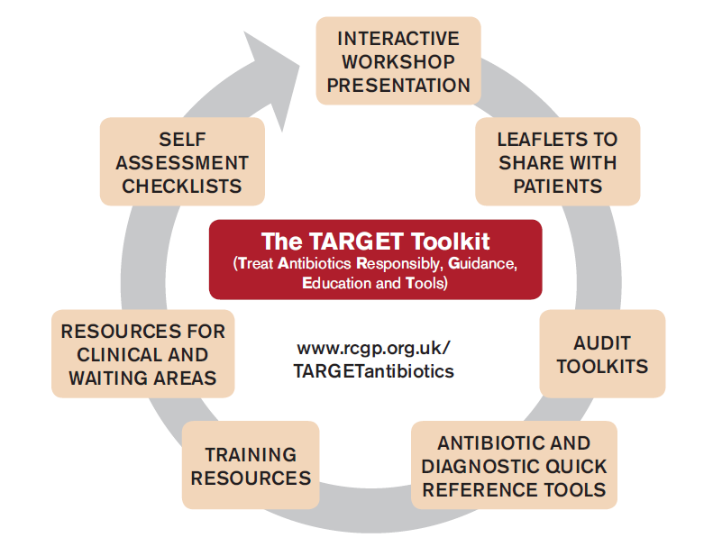

**For Prescribers and Commissioning Organisations**

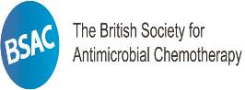

**Collaborating with:**



**Acknowledgements**

The TARGET resources were first developed by the Antimicrobial Stewardship in Primary Care (ASPIC) collaboration which was established in 2009 and includes: UK Health Security Agency (UKHSA) previously Public Health England (PHE); Royal College of General Practitioners (RCGP); Department of Health (DoH); British Society for Antimicrobial Chemotherapy (BSAC); Care Quality Commission (CQC); British Infection Association (BIA); Royal Pharmaceutical Society (RPS); National Prescribing Centre (NPC); Infection Prevention Society (IPS); British Paediatric Allergy, Immunology and Infectious Diseases Group (BPAIIG); Royal College of Nursing (RCN); Health Protection Scotland (HPS); Public Health Wales and Northern Ireland; NHS Information Centre; and interested GPs, pharmacists and microbiologists.

The ASPIC collaboration, working closely with primary care, has assessed current guidelines and other materials and, within a series of workshops, agreed the content of the TARGET Antibiotics Toolkit to promote antimicrobial stewardship.

Many thanks to all those who have helped develop this document or the TARGET resources, especially: Elizabeth Beech, Diane Ashiru-Oredope, Amanda Bunten, Ruth Dale, Matthew Dryden, Chris Butler, Nick Frances, Phillip Howard, Steve McCormick, Philippa Moore, RCGP and BSAC.

**Contents Page**

[1. Background 4](#_Toc509413924)

[1.1 The national context 4](#_Toc509413925)

[1.2 Theoretical Background – Theory of Planned Behaviour 5](#_Toc509413926)

[2. Introduction to TARGET 6](#_Toc509413927)

[2.1 What this Toolkit aims to attain 6](#_Toc509413928)

[2.2 What is included within the Toolkit 6](#_Toc509413929)

[3. Planning the delivery of the TARGET Antibiotics Toolkit – developing a local action plan 9](#_Toc509413930)

[4. The TARGET Antibiotics Toolkit resources 11](#_Toc509413931)

[4.1 Interactive workshop and presentation 11](#_Toc509413932)

[4.1.1 Organising the workshop 12](#_Toc509413933)

[4.1.2 Delivering the workshop – The TARGET Presentation 13](#_Toc509413934)

[4.1.3 Learning outcomes and agreeing follow-up 13](#_Toc509413935)

[4.1.4 After the workshop 13](#_Toc509413936)

[4.2 Supporting resources to promote at workshop and implement locally 14](#_Toc509413937)

4.2.1 Self-assessment checklist 14

[4.2.2 TARGET ‘Treating your Infection’ leaflets 14](#_Toc509413938)

[4.2.3 Audit toolkits 17](#_Toc509413939)

[4.2.4 Resources for clinical and waiting areas 17](#_Toc509413940)

[4.2.5 Antibiotic and Diagnostic Quick Reference Tools 18](#_Toc509413941)

[4.3 The TARGET UTI resource suite 18](#_Toc509413942)

[4.3.1 The Treating Your Infection – Urinary Tract Infection (UTI) leaflet 18](#_Toc509413943)

[4.3.2 The ‘Urinary tract infections (UTIs): A leaflet for older adults and carers’ 18](#_Toc509413944)

[4.3.3 The UTI quick reference diagnostic tools 19](#_Toc509413945)

[4.4 Training resources 19](#_Toc509413946)

[5. Self-care, other initiatives and sources of information 21](#_Toc509413947)

5.1 Keep Antibiotics Working and Antibiotic Guardian 22

[5.2 The Self Care Forum 22](#_Toc509413948)

[5.3 Other initiatives 22](#_Toc509413949)

[6. Reporting of laboratory antibiotic susceptibility testing 23](#_Toc509413950)

[7. Near-patient testing and algorithms 24](#_Toc509413951)

[8. Conclusions 24](#_Toc509413952)

[9. References 24](#_Toc509413953)

Uk Health Security Agency and Royal College of General Practitioners. The TARGET Antibiotics Toolkit: Guide to resources 2018. [www.RCGP.org.uk/TARGETantibiotics](http://www.RCGP.org.uk/TARGETantibiotics)

# Background

## 1.1 The national context

*“Antimicrobial resistance poses a catastrophic threat. If we don’t act now, any one of us could go into hospital in 20 years for minor surgery and die because of an ordinary infection that can’t be treated by antibiotics*.” Professor Dame Sally Davies, Chief Medical Officer, March 2013

*“No action today means no cure tomorrow.”* Dr Margaret Chan, WHO Director-General 2011

In the UK, 74% of antibiotic prescribing occurs in primary care1 with over half for respiratory tract infections. Countries and individual GP practices with greater use of antibiotics have greater bacterial resistance. Using antimicrobials responsibly can help minimise or delay the development of antimicrobial resistance and is pivotal in reducing the threat of antimicrobial resistance as outlined by Professor Dame Sally Davies in the quotation above. A number of key developments, measures and resources aim to support the responsible use of antibiotics in primary care. These include:

* The *Tackling antimicrobial resistance 2019–2024: the UK’s five-year national action plan*2 sets out ways of addressing resistance that tie into the larger 20 year year vision for AMR. For further information see: <https://assets.publishing.service.gov.uk/government/uploads/system/uploads/attachment_data/file/773130/uk-amr-5-year-national-action-plan.pdf>
* *The English Surveillance Programme for Antimicrobial Utilisation and Resistance(ESPAUR)*1*.* This programme, led by PHE, is developing and improving surveillance systems to measure antibiotic use and antibiotic resistance as well as measuring the impact of resistance of the safety of patients and the general public. For further information see: <https://www.gov.uk/government/publications/english-surveillance-programme-antimicrobial-utilisation-and-resistance-espaur-report>
* A range of national strategies and guidance produced by other home countries – for example the Scottish Antimicrobial Prescribing Group (<https://www.scottishmedicines.org.uk/SAPG>), the Welsh Antimicrobial Resistance Programme (<http://www.wales.nhs.uk/sites3/page.cfm?orgid=457&pid=28418>) and Northern Ireland’s Healthcare-associated Infection and Antimicrobial Stewardship Improvement Board <http://www.publichealth.hscni.net/antibiotic-awareness>.
* In 2015, NICE published its guideline entitled [Antimicrobial stewardship: systems and processes for effective antimicrobial medicine use4](https://www.nice.org.uk/guidance/ng15) and NHS England and Public Health England jointly issued a Patient Safety Alert, *Addressing antimicrobial resistance through implementation of an antimicrobial stewardship programme5*
* In 2017, NICE published its guideline [NG 63] entitled [Antimicrobial stewardship: changing risk-related behaviours in the general population](https://www.nice.org.uk/guidance/ng63)7.
* The Advisory Committee on Antimicrobial Resistance and Healthcare Associated Infection (ARHAI) recommended that primary care: should reduce total antibiotic prescribing; and reduce the proportion of cephalosporin, quinolone and co-amoxiclav classes through antimicrobial stewardship activities across all veterinary settings.
* The NHS England Antibiotic Quality Premium 2017/198 aims to reduce gram negative bloodstream infections and inappropriate antibiotic prescribing. The required performance in 2017/19 must be:
* a 10% reduction (or greater) in the number of *E coli* blood stream infections across the whole health economy; collection and reporting of a core primary care data set for all *E coli* blood stream infections.
* a 10% reduction (or greater) in the trimethoprim:nitrofurantoin prescribing ratio for UTI in primary care, based on CCG baseline data from 2015/16; a 10% reduction (or greater) in the number of trimethoprim items prescribed to patients aged 70 years or greater on baseline data from 2015/16.
* sustained reduction of inappropriate prescribing in primary care, in which items per STAR-PU must be equal to or below England 2013/14 mean performance value.
* Prescribing incentive schemes - many practices are subject to prescribing incentive schemes linked in with the measures highlighted above and linked to key indicators around prescribing. Reduced antibiotic prescribing may therefore have a positive impact on these incentives.

## 1.2 Theoretical Background – Theory of Planned Behaviour

The TARGET resources are based on the Theory of Planned Behaviour, one of the most widely used psychological models to explain human behaviour. The model proposes that human behaviour is driven by three considerations and these considerations are able to predict whether a person intends to do something. These are:

* **Personal Attitude** and outcome beliefs: Whether the person is in favour of doing something
* **Subjective Norm** and normative values: How much the person feels social pressure to do it
* **Perceived Behavioural Control** and control beliefs: Whether the person feels in control of the action in question

Thus, in order for prescribers (individual and teams), and patients to change their antibiotic use they need to:

* be convinced of the importance of antibiotic resistance and how their responsible antibiotic use can contribute to controlling resistance.
* have the confidence, motivation and tools to use antibiotics responsibly.

**Theory of Planned Behaviour Model**

**Personal Attitude**

* The belief that resistance is important.
* The belief that changes in prescribing will make a difference to antibiotic resistance.
* Any personal rewards for responsible prescribing.

**Action**

**planning**

**Monitoring**

**Audits**

**Self-Assessment**

**Subjective norms**

* Peers’ opinions about antibiotic prescribing.
* Pressure to prescribe responsibly from society or CCG.

**Behaviour**

**Perceived behavioural controls**

* Confidence to use antibiotics responsibly.
* Other barriers such as time, computers and cost influencing prescribing behaviour.

**Intention**

In this context, the TARGET Antibiotics Toolkit attempts to:

* influence **personal attitudes** to antibiotic resistance by emphasising the patient and population benefits of reducing antibiotic use and by showing that appropriate prescribing can make a difference to resistance;
* influence the **subjective norms** by raising awareness in the practice and nationally of the importance of antibiotic resistance and responsible prescribing, by feeding back practice prescribing rates compared to other practices locally and nationally and by describing the strategies used by peers to reduce antibiotic prescribing;
* influence **perceived behavioural controls by** increasing confidence of prescribers and patients to use antibiotics responsibly using guidance and leaflets and explaining how barriers to reducing antibiotic prescribing can be overcome.

Using a combination of the different TARGET resources can increase an individual’s intention to “use antibiotics responsibly”. However, other external barriers and patient characteristics may still influence or prevent responsible prescribing.

* Action planning within a practice or out of hours team is essential to move the intentions into actual actions.
* Audits are important to monitor changes in prescribing and highlight the need to discuss other external barriers.
* Incentives or indicators will influence behaviour through changing personal attitudes and subjective norms.

# Introduction to TARGET

TARGET stands for **T**reat **A**ntibiotics **R**esponsibly, **G**uidance, **E**ducation, **T**ools. This guide to the TARGET Antibiotics Toolkit aims to provide prescribers, commissioning organisations, TARGET trainers and facilitators with guidance on the materials and methods for implementing the Toolkit. As such, it is intended to be a working document and will be updated as new resources are developed or when there is significant changes to the content. We hope that the format enables users to understand and use the resources successfully to ensure responsible antibiotic prescribing.

The TARGET Antibiotics Toolkit has been developed by the UK Health Security Agency (UKHSA) Primary Care Unit, the Royal College of General Practitioners (RCGP) and the Antimicrobial Stewardship in Primary Care (ASPIC) Group. TARGET is the central resource to help prescribers and commissioning organisations improve antibiotic prescribing in primary care. It facilitates progress towards delivering quality improvement programmes to increase responsible antibiotic prescribing and can be found at: [www.RCGP.org.uk/TARGETantibiotics](http://www.RCGP.org.uk/TARGETantibiotics)

## 2.1 What this Toolkit aims to attain

The TARGET Antibiotics Toolkit aims to help influence prescribers’ and patients’ personal attitudes, social norms and perceived barriers to responsible antibiotic prescribing. It includes a range of resources that can each be used to support prescribers’ and patients’ responsible antibiotic use. To get maximum effect regarding antibiotic use, all or as many as possible of the resources should be used with action planning, by antimicrobial stewardship collaborations, clinical commissioning groups (CCGs), prescribers working within primary care, and CCG medicines management teams. Collectively, the TARGET resources will support practices in planning, implementing and reviewing activity in delivering quality improvement programmes relating to antimicrobial stewardship.

## 2.2 What is included within the Toolkit

The TARGET Antibiotics Toolkit includes the following resources:



The following table provides a guide to each of the components of the Toolkit and describes how it can be used flexibly and effectively.

**The TARGET Antibiotics Toolkit - resources, aims and benefits**

|  |  |  |
| --- | --- | --- |
| **TARGET Resource** | **Aims** | **Benefits** |
| **Interactive workshop presentation and clinical eModule**  (Section 4.1)  McNulty, C et al. Effects of primary care antimicrobial stewardship outreach on antibiotic use by general practice staff: Pragmatic Randomised Controlled Trial of the TARGET Antibiotics workshop; Journal of Antimicrobial Chemotherapy. 2018. | Based on clinical scenarios the interactive workshop highlights evidence and data on why optimising antibiotic prescribing is important and how it can be attained using the TARGET resources.  Aims to motivate staff and break down barriers to improved prescribing by influencing staff and patient personal attitudes, social norms and behaviour controls. | * Suitable for all members of the practice team. * Overview of current issues relating to AMR and how these can be managed effectively. * Online eModule version available for individual learning. * Full outline of TARGET resources and explanation of how these can be used to promote responsible antibiotic use. * Generates discussion on management of case studies and use of resources in the practice. * Promotes action planning to improve prescribing * To optimise effect we recommend that you include local data on antibiotic use. |
| **Self-assessment checklist**  (Section 4.2.1) | A short hardcopy and online assessment tool for practice staff and commissioning groups to assess their antibiotic prescribing strategies.  Aims to influence personal attitudes and subjective norms. | * Provides better understanding of current prescribing practice and strategies that can help to optimise antibiotic prescribing in primary care. * Allows you to compare your antimicrobial stewardship to other practices in your CCG and nationally. |
| **TARGET ‘Treating your Infection’ leaflets**  (Section 4.2.2)  Bunten AK, et al. Patient information can improve appropriate antibiotic prescribing. Nursing in Practice. 2015 Feb; 82(1):55-57. | To be shared with patients during consultations to inform them about how to manage infections without the use of antibiotics.  Aims to influence patients’ and clinicians’ confidence to use antibiotics responsibly (overcoming perceived barriers to improved antibiotic use). | * All leaflets are endorsed by NICE * Influence patients’ and clinicians’ confidence to use antibiotics responsibly for RTI and UTI. * Improves patient understanding of infections/antibiotics. * Clinicians can close the consultation by providing a leaflet rather than a prescription. * Reduce re-consultation rates by encouraging self-care. * Can be used to give safety-netting advice. * Easy to reproduce and linked to IT systems including patient.co.uk, EMIS and SystmOne. |
| **Audit toolkits and action planning**  (Section 4.2.3)  Jones LF, et al. An evaluation of the TARGET (Treat Antibiotics Responsibly; Guidance, Education, Tools) Antibiotics Toolkit to improve antimicrobial stewardship in primary care—is it fit for purpose? Fam Pract. 2017. | Templates to assist in accurate and easy completion of antibiotic prescribing and infection audits by including Read codes, current guidance and action plans.  Aims to influence personal attitudes and social norms and encourages action planning. | * Measure of adherence to current guidelines. * Allows clinicians to assess consistency of approach across the practice. * Facilitates action planning for local prescribing practice. * Can be used as supporting evidence in revalidation. |
| **Resources for clinical and waiting areas**  (Section 4.2.4)  Lecky DM, et al. Animations designed to raise patient awareness of prudent antibiotic use: patient recall of key messages and their immediate effect on patient attitude. BMC Research Notes. 2017;10:701. doi:10.1186/s13104-017-3048-0. | A series of posters & videos that can be used to change patient expectations for antibiotics.  Aim to influence social norms. | * Easy to digest visual guides informing patients about appropriate antibiotic use. * Can refer to in consultation to raise importance of responsible antibiotic use. |
| **Antibiotic and Diagnostic Quick Reference Tools**  (Section 4.2.5) | A series of National evidence based antibiotic and diagnostic quick reference tools.  Aims to influence social norms and increase confidence of prescribers. | * Quick and accurate reference tools on management of common infections with full rationale and evidence base. * Can be adapted locally. * Can be used for training. * Can be printed in poster format. |
| **TARGET UTI Resource Suite**  (Section 4.3) | This section provides an overview of the TARGET resources that are available to facilitate appropriate prescribing and diagnosis of Urinary Tract Infections (UTIs) and how they can be used. | * Fully referenced patient information leaflets for uncomplicated UTIs and for the elderly * Quick and accurate reference tools on management of UTIs with full rationale and evidence base. |
| **Training resources**  (Section 4.4) | FREE clinical training resources including an interactive series of 7 webinars, the TARGET presentation and eModules.  Aim to influence personal attitudes, subjective norms and barriers to prescribing. | * Easily accessible courses in managing common infections and improving communication with patients. * Contain many clinical scenarios. * Contain videos using consultation techniques. * Interactive webinars include short video and Q&A sessions. * Obtain CPD points. * Suitable for nurse prescribers. |

# Planning the delivery of the TARGET Antibiotics Toolkit – developing a local action plan

To maximise the improvement in responsible antibiotic use we recommend that **ALL** resources are used if this is feasible so that all components of the Theory of Planned Behaviour are influenced. However the resources can be used flexibly, either as standalone materials or as part of an integrated package. They can be downloaded from the TARGET Antibiotics website ([www.RCGP.org.uk/TARGETantibiotics/](http://www.RCGP.org.uk/TARGETantibiotics/)) and adapted for local use. A recent rigorous RCT evaluation in routine general practice showed that a one hour TARGET workshop given by local GPs, microbiologists or medicine managers, combined with demonstrating the resources, significantly reduced antibiotic use9.

It is essential to plan and monitor implementation of the TARGET Antibiotics Toolkit appropriately and this is best achieved by developing a local antibiotic action plan, either for your CCG or your practice. It is important that this plan is developed using a whole team approach so that everyone who is involved in communication and prescribing around antibiotics has had the opportunity to contribute.

Each CCG and practice has different prescribing pressures and priorities. It is therefore also important that prescribers take ownership of the planning process as well as the adaptation and implementation of resources at a local level.

Before beginning the planning process we recommend you appoint a local antibiotic champion from within the CCG or the practice. This is someone who has responsibility for leading on all issues relating to antibiotics and leads the development and implementation of the antibiotic action plan.

In order to maximise effectiveness of the TARGET resources, users should plan, monitor and review the implementation as part of a cyclical process as follows:

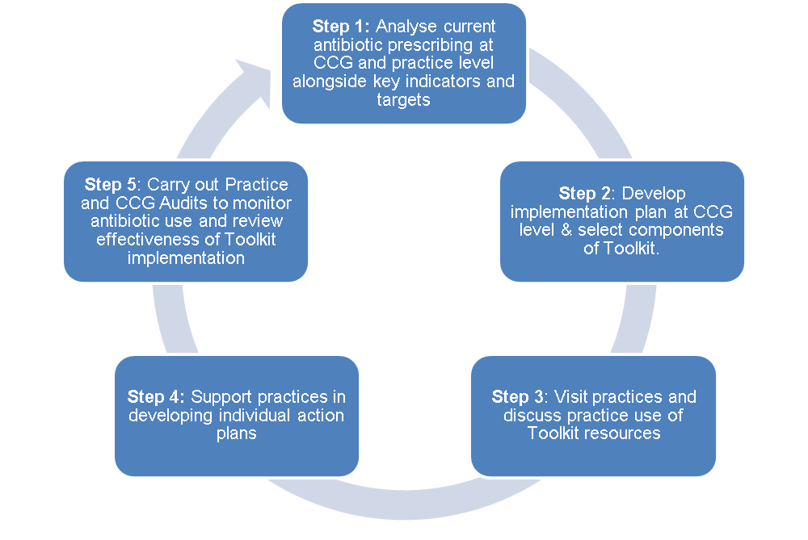**Planning the delivery of the TARGET Antibiotics Toolkit**

**Step 1: Analyse current antibiotic practice within CCG (scoping exercise)**

The recommended starting point is to obtain an overall perception of current prescribing practice at CCG or area level and subsequently at practice level. This can be achieved using national prescribing data on [fingertips](https://fingertips.phe.org.uk/), [prescQIPP](https://www.prescqipp.info/) or [open prescribing](https://openprescribing.net/).

**Step 2: Develop implementation plan at CCG or area level and select components of the Toolkit**

**2a: Develop implementation plan**. The implementation plan should relate to discussions at CCG or locality level. This should include development of organisational objectives and key performance indicators. Planning should include all appropriate stakeholders and incorporate target setting at locality level regarding antibiotic use and prioritisation of practices.

During this stage, contact with Practices should involve discussion of aspirations relating to antibiotic prescribing using information obtained from the scoping exercise in Step 1. It should also include discussions of the mechanisms by which TARGET can be delivered in each practice (see Step 2b).

**2b: Select components of the TARGET Antibiotics Toolkit and develop plan for use of resources**

The components of the TARGET Antibiotics Toolkit are described in detail in Section 4 of this guide. Broadly, the different options of *delivering* the Toolkit include:

1. **TARGET workshops with groups of practices**, ideally involving all antibiotic prescribers and those involved in triaging patients. Workshops should include the presentation, discussion around antibiotic usage data, how to use and develop a practice action plan. At least 60 minutes, ideally 90 minutes, is needed to cover all issues in appropriate detail.
2. **Attendance at TARGET workshop for all staff at individual practices,** a practice discussion and plan of action. Workshops should include the presentation, discussion around antibiotic usage data, how to use and develop a practice action plan. At least one hour is needed.
3. **Completion of online** [TARGET Antibiotic Resistance in Primary Care eModule](http://elearning.rcgp.org.uk/course/info.php?popup=0&id=167) **individually by primary care clinicians followed by a practice meeting** of all staff to discuss use of resources and ensuing plan of action.
4. **CCGs can simply circulate links to the resources that are available with integration into clinical computer systems**. However, this is unlikely to lead to much change in antibiotic use and is therefore the least favoured option.

More specific detail on the materials available in the TARGET Antibiotics Toolkit is provided in section 1.2. Selection will depend on the level of need identified in the scoping exercise at Step 1 and the level of resources available.

**Step 3: Visit practices and/or practices use resources**

This is the main implementation phase of the Toolkit and should include:

* The workshop
* Discussion around practice prescribing and how the practice aims to use possible resources and implement them into daily practice
* Identification of an antibiotic champion within the practice

**Step 4: Support practices in developing individual action plans**

The practice action plan ideally should be developed during the workshop and set out current antibiotic usage and an outline of future plans. This should include:

* Overall aim for change in antibiotic use and defined measurable targets (use QP indicators with a locally agreed reduction target)
* How the practice aims to achieve this implementation, with responsibilities for actions
* How leaflets can be incorporated into the practice computer, and by whom and when
* Who is responsible for posters/videos
* Audit plans and responsible staff member

**Step 5: Practice and CCG monitoring of antibiotic use and review**

Once a practice plan of action has been implemented, it is essential tomonitor and review regularly. We recommend six monthly reviews at both practice and CCG/area level.

Ask such questions as: To what extent are we reaching our antibiotics prescribing target? If not, why not? What do we need to put in place to ensure we continue to make appropriate progress?

Resources to help with this include:

* The self-assessment checklist
* Audit toolkits

# The TARGET Antibiotics Toolkit resources

The TARGET Toolkit resources are all freely available on the RCGP website [www.RCGP.org.uk/TARGETantibiotics/](http://www.RCGP.org.uk/TARGETantibiotics/)

Many of the resources are available in MS Word format so that you can make minor changes and adapt to meet local needs. To do this, you may download and save the document locally, removing endorsement logos if you make substantial changes to the wording content. Most of the resources are also available in .pdf format which is printer friendly and for those who wish to use the resource as it is.

This section provides an overview of the resources that are available and how they can be used.

## 4.1 Interactive workshop and presentation

The workshop is a comprehensive resource that comprises an interactive presentation and an opportunity to see and take away all the Toolkit materials. It can be adapted and delivered in a way that meets local needs and priorities. The workshop highlights the most up to date evidence and data on why optimising antibiotic prescribing is important and how this can be achieved using TARGET.

The workshop covers the following:

1. Interactive workshop including:
   * A brief background into antimicrobial resistance
   * A discussion of clinical cases and where antibiotic prescribing can be improved. For each case:

* Discuss the value of, and how to implement the TARGET website materials (Patient leaflets, Audit toolkits, Antibiotic diagnostic quick reference tools, Training resources, Posters and videos to increase patient and staff awareness)
* Show the evidence that:
* antibiotic resistance is a problem in primary care
* antibiotic use in primary care is important and influences resistance
* decreasing antibiotic use can delay the development of antibiotic resistance, and reduce the risk of antibiotic associated Clostridium difficile infections
  + Local antibiotic prescribing data

1. How to develop a practice antibiotic prescribing action plan

### 4.1.1 Organising the workshor to the workshop it is important that presenters familiarise themselves with key documents, strategies and resources including:

* National strategies and papers (see Section 2.1), including [Tackling antimicrobial resistance 2019–2024: the UK’s five-year national action plan](https://assets.publishing.service.gov.uk/government/uploads/system/uploads/attachment_data/file/773130/uk-amr-5-year-national-action-plan.pdf)2, the [2017-19 Quality Premium](hhttps://www.england.nhs.uk/ccg-out-tool/qual-prem/)8 [and the NICE Guideline Antimicrobial stewardship: systems and processes for effective antimicrobial medicine use4](https://www.nice.org.uk/guidance/ng15)
* Local antibiotic guidance;
* Local CCG or area plans, targets and priorities around antimicrobial stewardship; and
* All of the TARGET Antibiotic Toolkit resources.

The following step-by-step table will help guide you through workshop organisation:

|  |  |  |
| --- | --- | --- |
| **Step** | **Action** | **Document to use\*** |
| 1 | Send invitation letter to practice. Including prescribing data which may encourage attendance. | Invitation letter template. |
| 2 | If practice accepts, book workshop date over the phone. If not, send follow-up invitations with a telephone call and check if practice would prefer a hard copy letter. | Follow-up invitation template. |
| 3 | Send confirmation letter to practice (14 days in advance). | Confirmation letter template. |
| 4 | Check whether surgery has presentation facilities such as laptop, extension cable, projector, pens (14 days in advance) |  |
| 5 | Confirm how practice wants to approach workshop programme and time available - full workshop or just presentation of resources after they have completed online training (14 days in advance). |  |
| 6 | Send Self-Assessment Checklist to clinicians in advance of the workshop for completion (14 days in advance). | Printable Self-Assessment Checklist. |
| 7 | Print out resources (7 days in advance). | Resource Checklist. |
| 8 | Remind yourself of information pertaining to that surgery (7 days in advance):   1. main contact name 2. staffing 3. services offered 4. antibiotic prescribing rates compared with others in CCG and changes over last 5 years and modify presentation to include this data. | Local practice records. |
| 9 | Ring surgery on morning of workshop as visit reminder. |  |
| 10 | On arrival suggest staff discuss and complete the following while they await colleagues:   1. Training Session Attendance Sheet 2. Self-assessment checklists if not already completed | Training Session Attendance Sheet, TARGET self-assessment checklist. |
| 11 | Deliver training and presentation, present resources, agree action plan. | TARGET workshop presentation and all Toolkit materials. |
| 12 | At the end of the session ask staff attending to complete post training evaluation form requesting feedback. | Workshop Evaluation Sheet. |
| 13 | Provide CPD certificate at or after workshop | Workshop CPD certificate. |
| 14 | Monitor progress quarterly using national prescribing data on [fingertips](https://fingertips.phe.org.uk/), [prescQIPP](https://www.prescqipp.info/) or [open prescribing](https://openprescribing.net/). | Department of Health QIPP Prescribing Comparators (Antimicrobials, Medicines Pharmacy and Industry)  March 2014. |

### 4.1.2 Delivering the workshop – The TARGET Presentation

The TARGET presentation forms the main part of the TARGET workshop. It outlines why optimising antibiotic prescribing is important and how this can be achieved. It will need to be modified with the following information so that it is relevant to practices in a specific area:

* Local antibiotic prescribing information available from ePACT data, PrescQIPP, NHS BSA, Fingertips or OpenPrescribing
* NHSBSA National Antibiotic QIPP prescribing indicators (available to NHS staff who are registered with the NHSBSA Information Portal)

As we have already mentioned, antibiotic prescribing data is key to understanding the extent of local prescribing activity and therefore to establishing appropriate action plans and optimising the responsible use of antibiotics. Feedback from GP staff indicates that this is the most valuable part of the workshop.

The TARGET presentation is included on the TARGET website ([www.RCGP.org.uk/TARGETantibiotics](http://www.RCGP.org.uk/TARGETantibiotics)) under the headings *Training Resources → TARGET “why and how to achieve optimal prescribing” group training presentation*. The presentation is available to download and has accompanying notes for each of the slides.

### 4.1.3 Learning outcomes and agreeing follow-up

This table denotes the main learning outcomes of the workshop – these are the essential points that should be covered during the workshop with clinicians.

|  |  |
| --- | --- |
| **Key Message** | **Justification/ Notes** |
| Antibiotic use is increasing (refer to practice data). | National and local ePACT data in presentation. |
| Antibiotic resistance in individual patients, in CCGs and nationally is related to prescribing. | Background evidence in presentation. |
| Reducing antibiotic use can reduce antibiotic resistance and patient consultations. | Background evidence in presentation. |
| Evidence-based antibiotic guidance should be followed. | After each clinical scenario in presentation, local and national guidance notes and rationale. |
| Patient centred communication reduces prescribing. Using the TARGET leaflets help the patient to self-care and facilitates safety netting. | Previous research and information referred to in the TARGET Antibiotics Toolkit and discussion of leaflet. |
| Back-up/delayed antibiotic prescribing reduces overall prescribing and future consultations.  The TARGET leaflet helps to facilitate this.  Read codes should be used when information leaflets and/or back-up/delayed prescribing are used. | Evidence of benefit and use of back-up prescribing in presentation; patient information leaflet in TARGET Antibiotics Toolkit. |
| Understanding of how the practice prescribing compares with other practices and has changed within the practice. | Showing a practice its prescribing has been a very important motivator for change. |
| Audits inform prescribing and target improvements in prescribing. | Audits help motivate and enforce behaviour.  Audits in TARGET Antibiotics Toolkit. |
| The self-assessment checklist enables reflection on current antibiotic use and prescribing behaviour. | Self-assessment checklist in the TARGET Antibiotics Toolkit. |

We suggest you ask a named contact such as the practice prescribing lead or the antibiotic champion if you can call them to see how they are getting on with the materials and obtain feedback on progress made. Make a note of any oral feedback or impressions from the session.

### 4.1.4 After the workshop

What you do after the workshop will depend on your local area and practice action plan and priorities. We suggest:

* Analyse the self-assessment checklists. This will allow you to evaluate current practices and measure change. We recommend repeating the self-assessment after 6 and 12 months.
* Analyse the evaluation forms. This will allow you to assess the value of the workshops and the expertise of the presenter and therefore enable improvements to be made if appropriate.
* Analyse the attendance sheets. This will allow you to send out CPD certificates, and determine how many and what percentage of primary care clinicians have attended workshops in your CCG and in particular practices. This will be important to inform any reasons for success or failure of the workshops and facilitate change in antibiotic use.
* Arrange a further visit or telephone contact to discuss resource use, setting up computer prompts, meet other members of the team who could not attend, discuss audits and other ways forward.

## 4.2 Supporting resources to promote at workshop and implement locally

**4.2.1 Self-assessment checklist**

This tool is a short questionnaire for use by GP practices and commissioning groups to assess what stakeholders and prescribers are already using to improve antibiotic prescribing. It should signpost prescribers and practices towards different strategies they can use to optimise their antibiotic prescribing in primary care. Completion of the self-assessment checklist can earn CPD points. The checklist is available in two formats: (i) printable format for use before workshops or teaching sessions; (ii) online version on the RCGP website with which users can compare their performance against others who have already completed the assessment.

The checklist can be accessed in online and downloadable formats from [www.RCGP.org.uk/TARGETantibiotics](http://www.RCGP.org.uk/TARGETantibiotics)

### 4.2.2 TARGET ‘Treating your Infection’ leaflets

The patient information leaflets have been the most popular and widely used part of the TARGET resources. They can be found on the TARGET website ([www.RCGP.org.uk/TARGETantibiotics](http://www.RCGP.org.uk/TARGETantibiotics)) under the heading *Leaflets to share with patients*. The ‘Treating your infection’ (TYI) leaflets have been developed through extensive feedback with patients and clinicians over the last 4 years. They are designed to be shared with patients and completed with them during the consultation. They aim to increase the patient’s confidence to self-care, and to facilitate the use of a back-up antibiotic prescription, but also allow the patients to go away with something, so ending the consultation on a positive note.

Current leaflets available in the Treating your Infection range are:

* **The Treating Your Infection – Urinary Tract Infection (UTI) leaflet**

The TYI-UTI patient Information leaflet has been designed to be used with women who are experiencing urinary symptoms suggesting non complicated UTIs. This leaflet accurately reflects recommendations in the NICE guidelines on [**antimicrobial stewardship**](https://www.nice.org.uk/guidance/ng15) and [**urinary tract infections**](https://www.nice.org.uk/guidance/ng109).

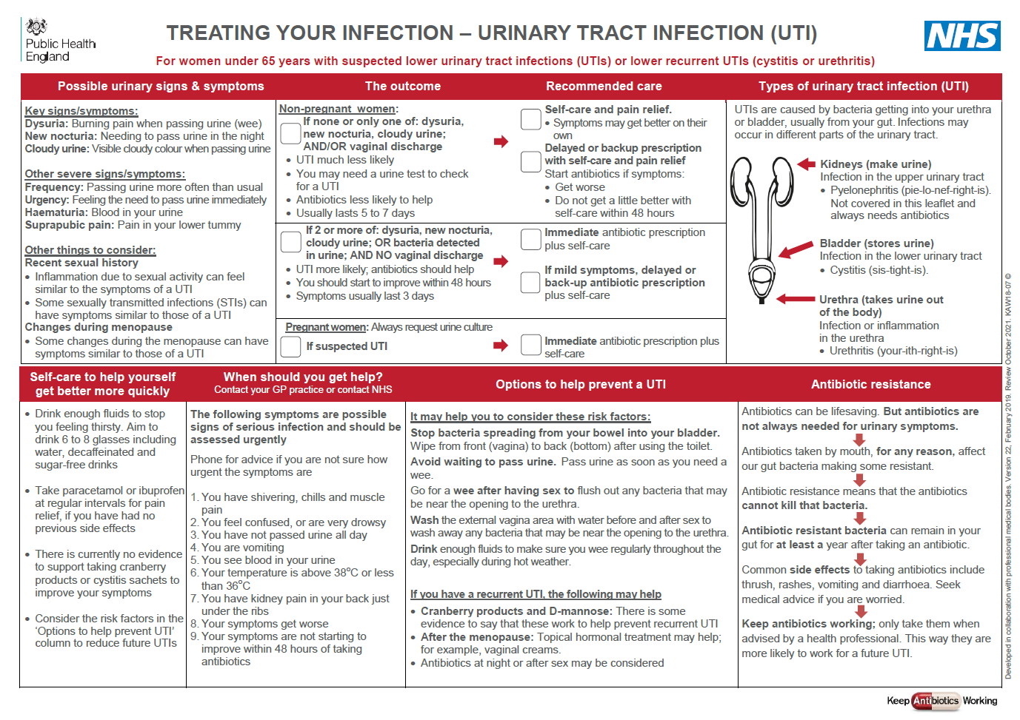

* **The Treating Your Infection – Respiratory Tract Infection (RTI) leaflet**

The TYI-RTI patient Information leaflet has been designed to be used with patients who are experiencing self-limiting uRTIs. This leaflet supports implementation of recommendations in the NICE guidelines on [**processes for antimicrobial stewardship**](https://www.nice.org.uk/guidance/ng15), [**behaviour change for antimicrobial stewardship**](https://www.nice.org.uk/guidance/cg69) and [**antibiotic prescribing for respiratory tract infections**](https://www.nice.org.uk/guidance/ng63).

The TYI-RTI leaflet is available for the following settings

* + Use in community settings (pictorial leaflet for those with lower reading ability)
  + Use in community pharmacy
  + Use in out of hours settings

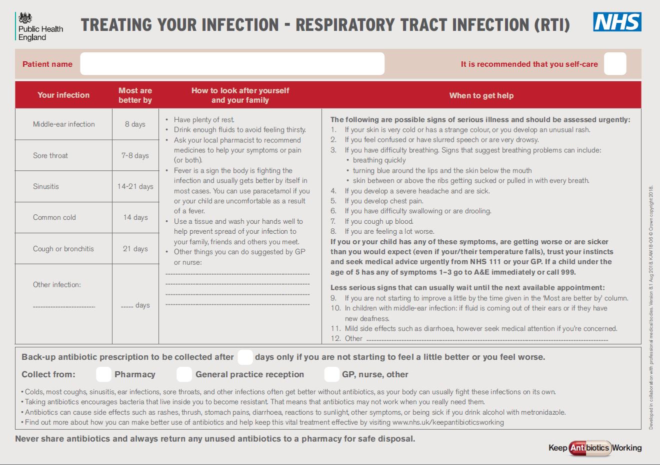

To maximise the benefit of these leaflets, they should be used as a tool to interact with patients in the consultation, rather than as a ‘parting gift’. We suggest that practitioners make sure that they are very familiar with its content. Clinicians should take some time to thoroughly familiarise themselves with the leaflets and read the leaflet user guides before starting to use the leaflets.

The ‘**most get better by**’ section allows patients to understand not only for this consultation, but also others, when they should consult. This section has consistently been seen as very useful by patients of all ages.

**Safety netting (When should you get help):** whatever the infection, in this era of antibiotic resistance and with increasing numbers of elderly or vulnerable patients, it is extremely important to give some clear safety netting instructions. The leaflet lists those identified by clinicians as relevant and can be used and saved by patients. Others can also be added as required depending on the particular infection.

**The back-up prescription** can reduce antibiotic prescribing by about 30 to 40%, and is extremely useful for particularly demanding patients or just before a weekend to reduce visits to out of hours services. Depending on local policy, back-up prescriptions can either be post-dated and given to the patient, or left at the reception desk or local pharmacy for the patient to pick up using an electronic ‘prescribing token’.

**Advice about antibiotic resistance and use:** although most patients know they shouldn’t take antibiotics for coughs and colds, far fewer know that sinusitis, ear infections, sore throats and many other infections get better on their own without antibiotics. Likewise they know little about antibiotic resistance, so we should take every opportunity to educate them. It is also important to stress not to share antibiotics. Prescribers can also inform patients about drinking alcohol and taking antibiotics – current advice is that moderate alcohol intake with most antibiotics is safe, except for metronidazole.

**Specific Read codes** – when using the leaflet, practitioners ideally would use one of the following Read codes:

EMIS web codes - 8BP0 (deferred antibiotic therapy), 8OA9 (provision of written info about antibiotic therapy), 8CAk (patient advised to delay filling of prescription), 8CE (self-help advice leaflet given).

TPP codes – XaKYH (deferred antibiotic therapy), XaaJM (provision of written information about antibiotics).

This will enable you to audit your use of the leaflet and can be used to record ‘no’ or ‘back-up’ prescription decisions for appraisal and monitoring purposes. If possible, setting the leaflet up on the computer system to automatically appear for common infection keywords will facilitate its use.

NB: Read codes will change to Snomed codes during 2018/19 and the resources will be updated accordingly.

## 4.2.3 Audit toolkits

Audit is a useful way for prescribers to determine if they are prescribing according to current guidelines. It is also a necessary part of revalidation and can be included as supporting evidence in a revalidation portfolio.

Completing prescribing audits can sometimes be a difficult and laborious process, so TARGET has developed some ready-made audit toolkits. These are to assist in accurate and easy completion of an audit by including Read codes, current guidance and action plans.

The TARGET Antibiotics Toolkit currently includes templates for audits in sore throat, UTI, otitis media, acute cough, rhinosinusitis and otitis externa. These can be found on the TARGET website ([www.RCGP.org.uk/TARGETantibiotics](http://www.RCGP.org.uk/TARGETantibiotics)) under the heading *Audit toolkits and action planning.*

## 4.2.4 Resources for clinical and waiting areas

You may have seen the posters or videos about not using antibiotics routinely for coughs and colds. Posters and videos can make a difference to patient opinions about when to expect antibiotics. They can be used as a “hook” during consultations to introduce the topic of a back-up or a no antibiotic option – eg “*You may have seen that our practice is using posters to encourage responsible antibiotic use…*” In 2014, 25% of the general public surveyed remembered seeing the first poster and 95% of these correctly answered that antibiotics don’t help most coughs and colds3.

Posters for display:





It is helpful to assign one member of staff within the practice responsibility for ensuring posters are displayed appropriately and include these within a health promotion plan.

Videos for waiting areas:

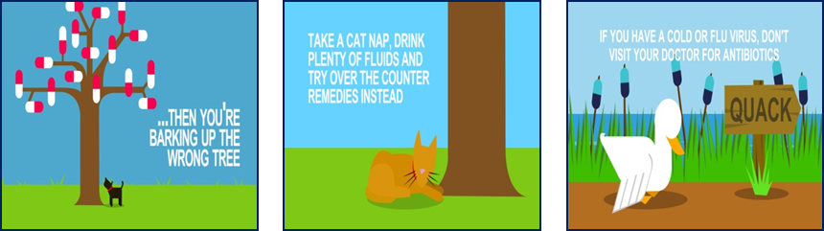

It is important if videos are used to ensure that the video sound is on and the seats in the waiting areas face the screens. IF used in the waiting room where patients can see them and IF they have the time to digest the information, they can help improve knowledge about appropriate antibiotic use.

All posters and videos are available to download from the TARGET website [www.RCGP.org.uk/TARGETantibiotics](http://www.RCGP.org.uk/TARGETantibiotics)

Or contact us to get other formats at: [TARGETantibiotics@phe.gov.uk](mailto:TARGETantibiotics@phe.gov.uk)

## 4.2.5 Antibiotic and Diagnostic Quick Reference Tools

The TARGET Antibiotics Toolkit includes the UK Health Security Agency and NICE evidence based antibiotic diagnostic quick reference tools which can be adapted locally. Each tool has an extensive rationale section for trainers and trainees, or just when you want a bit more information for yourself or the patient. These quick reference tools incorporate NNT data which is immensely useful when communicating with some patients and colleagues.

The quick reference tools can be found on the TARGET website ([www.RCGP.org.uk/TARGETantibiotics](http://www.RCGP.org.uk/TARGETantibiotics)) under the heading *Antibiotic & Diagnostic Quick Reference Tools.*

## 4.3 The TARGET UTI Resource Suite

This section provides an overview of the TARGET resources that are available to facilitate appropriate prescribing and diagnosis of Urinary Tract Infections (UTIs) and how they can be used.

### 4.3.1 The Treating Your Infection – Urinary Tract Infection (UTI) leaflet

The TYI-UTI patient Information leaflet has been designed to be used with women who are experiencing urinary symptoms suggesting non complicated UTIs. The TYI-UTI leaflet was developed using the Theoretical Domains Framework behavioral science model, following feedback from patients, GPs and other stakeholders and is evidence based. This leaflet has been endorsed by NICE and supports implementation of recommendations in the NICE guidelines on [**antimicrobial stewardship**](https://www.nice.org.uk/guidance/ng15) and [**urinary tract infections**](https://www.nice.org.uk/guidance/ng109).

The leaflet is designed to be used during consultation to facilitate dialogue between the patient and the prescriber, it is important that it is used as a tool to interact with patients, rather than as a ‘parting gift’. In order to do this effectively you should be familiar with its content.

### 4.3.2 The ‘Urinary tract infections (UTIs) A leaflet for older adults and carers’

The leaflet has been developed following extensive needs assessment with GPs, care home staff, care home residents, relatives and a wide range of stakeholders. It is evidence based and was developed using Theoretical Domains Framework behavioral science model. The leaflet was designed to be given to older adults in various levels of care who may be at risk for UTI, have a suspected UTI or urinary symptoms. It provides easy to read information on possible ways to prevent UTIs, how UTIs are diagnosed and managed, self-care and information on when to re-consult. The UTI leaflet for older adults will form an important part of improving the management of UTIs in line with the 2017/18 Quality Premium. This leaflet has been endorsed by NICE and supports implementation of recommendations in the NICE guidelines on [**antimicrobial stewardship**](https://www.nice.org.uk/guidance/ng15) and [**urinary tract infections**](https://www.nice.org.uk/guidance/ng109).

The leaflet can be used in several ways. To provide information on UTIs to those at risk, care staff may wish to share this leaflet with older adults in their care and/or their relatives. The leaflet may also be used during primary care consultations to facilitate dialogue between a patient and their GP on specific topics like treatment or safety netting.

### 4.3.3 The UTI quick reference diagnostic tools

The aim of the UTI quick reference diagnostic tools is to provide a simple, effective, economical and empirical approach to the diagnosis and treatment of urinary tract infections and to minimise the emergence of antibiotic resistance in the community. They have been developed to be used by primary care prescribers in general practice and out of hours settings; including doctors, nurses and pharmacists and others who may be giving first point of contact for urinary tract infections. They aim to improve the diagnosis of UTI, pyelonephritis and sepsis.

The tools has been produced in consultation with key stakeholders including general practitioners, nurses, specialists, and patient representatives. The UTI tools include a separate flowchart for uncomplicated UTI in children, women under 65 years and those over 65 years of age. The flowcharts clearly outline recommendations for steps along the diagnostic pathway and include summary tables that provide information. The information is evidence based, graded, and provided with an extensive rationale section. This diagnostic tool has been endorsed by NICE and supports implementation of recommendations in the NICE guidelines on [**antimicrobial stewardship**](https://www.nice.org.uk/guidance/ng15) and [**urinary tract infections**](https://www.nice.org.uk/guidance/ng109).

## 4.4 Training resources

The TARGET Antibiotics Toolkit provides a range of free clinical training resources. These include: group training via the TARGET Antibiotics presentation; a series of interactive webinars developed with BSAC, the MUTS programme for Managing Urinary Tract Infections (UTIs); the MARTI programme for Managing Respiratory Tract Infections (RTIs); the MOSI programme covering the Management of Skin Infections; a module covering Infectious Diarrhoea and the STAR programme. The aim of all these training resources is to raise awareness of how antibiotic prescribing can influence resistance, and inform prescribers about strategies to improve prescribing in general.

**TARGET Training Resources Summary**

|  |  |
| --- | --- |
| TARGET Antibiotics Clinical Course (eModule) | This RCGP online clinical course for personal training and reflection aims to provide up to date evidence and surveillance data to primary care clinicians about why optimising antibiotic prescribing is important and how this can be achieved. It lasts 40 – 60 minutes and includes slide notes and references.  <http://elearning.rcgp.org.uk/course/info.php?popup=0&id=167> |
| MARTI Managing Acute Respiratory Tract Infections | This RCGP online clinical course for personal training enables practitioners to improve the care they provide to patients presenting with acute ear pain, acute sore throat, sinusitis and acute cough. The module equals two hours toward CPD, and can import into the RCGP Revalidation portfolio.  <http://www.rcgp.org.uk/courses-and-events/online-learning/ole/managing-acute-respiratory-tract-infections.aspx> |
| MUTS Managing Urinary Tract Infections | This RCGP online clinical course explains the importance and appropriateness of diagnostics and offers advice on how to assess and treat patients with a range of urinary symptoms. It encourages reflection on how to minimise antibiotic resistance and offers 'real-life' cases. The module equals 1.5 hours toward CPD, and can be imported into the RCGP Revalidation portfolio.  <http://www.rcgp.org.uk/courses-and-events/online-learning/ole/urinary-tract-infections.aspx> |
| STAR Stemming the Tide of Antimicrobial Resistance | STAR is a theory based ‘blended learning’ programme to promote appropriate antibiotic prescribing and focuses on communication with the patient. The STAR programme was led by Professor Chris Butler and developed by a team at Cardiff University.  <http://www.stemmingthetide.org/> |
| MOSI Managing of Skin Infections | Skin infections are commonly seen in general practice. With ever increasing rates of antibiotic resistance, it is important for GPs to feel confident about making a diagnosis and to understand when antibiotic treatment is indicated. This course describes common presentations of bacterial, viral and fungal skin infections and outlines their management. The module is 2 hours and counts toward CPD, and can be imported into the RCGP Revalidation portfolio.  [www.elearning.rcgp.org.uk/skininfections](http://www.elearning.rcgp.org.uk/skininfections) |
| Managing Infectious Diarrhoea | Infection diarrhoea is a common presentation to general practice. Most cases are self-limiting and require only advice but further investigations and treatment are sometimes needed. This course uses case studies to illustrate various points in the clinical management of patients with infectious diarrhoea as well as covering the public health issues involved.  <http://www.rcgp.org.uk/learning/online-learning/ole/managing-infectious-diarrhoea.aspx> |
| TARGET Webinars | Originally hosted as live webinars these seven 50 minute learning modules are now available as un-facilitated learning courses, each containing presentations, recorded panel discussions and a host of referenced material and learning resources. [www.TARGET-webinars.com](http://www.TARGET-webinars.com) |

# Self-care, other initiatives and sources of information

The TARGET website also has links to other sources of information for patients. These include:

|  |  |
| --- | --- |
| Patient information resource | Guide to content |
| [When should I worry? booklet](http://www.whenshouldiworry.com/) | Information for parents about the management of respiratory tract infections such as coughs, colds, sore throats and ear aches in children.  Developed by Cardiff University, its use has been evaluated in a randomised controlled trial and demonstrated a two-thirds reduction in antibiotic prescribing without impacting on parental satisfaction. |
| [Get well soon without antibiotics](https://www.gov.uk/government/uploads/system/uploads/attachment_data/file/357104/3-PC-Get-well-soon-without-antibiotics1.pdf) | This leaflet, produced by the Department of Health, explains the need to get the right treatment for common illnesses such as colds and coughs without encouraging antibiotic resistance. It is available in different languages. |
| Caring for children with coughs  <http://www.bristol.ac.uk/media-library/sites/primaryhealthcare/documents/target/caring-for-children-with-cough-leaflet-print-ready.pdf> | This leaflet contains information about how to look after a child who has a cough (not due to asthma). For more detail see [www.bristol.ac.uk/child-cough](http://www.bristol.ac.uk/child-cough) |
| [www.patient.co.uk](http://www.patient.co.uk) | The patient.co.uk website has useful patient information leaflets about all minor illnesses and self -management options. The TARGET ‘Treating your infection’ leaflet is also hosted on the [www.patient.co.uk](http://www.patient.co.uk) website. |
| Treat yourself better  <http://www.treatyourselfbetter.co.uk/> | The treat yourself better website has a symptom checker for colds and flu as well as promoting the message that antibiotics do not work for these symptoms. |
| Medicines for Children website  [www.medicinesforchildren.org.uk](http://www.medicinesforchildren.org.uk) | The Medicines for Children website provides information for parents and carers about giving medicines to children, written and reviewed by doctors, pharmacists, parents and carers. Designed to help our future generation understand why we need to use antibiotics appropriately. |
| e-Bug  [www.e-bug.eu](http://www.e-bug.eu) | e-Bug is a free educational resource for junior (9-11 years) and senior (12-15 years) school students, and young adults (15-18 years) across Europe covering antibiotic use, microbes, their spread and prevention. Designed by schools and young people, and endorsed by the Departments of Education and Health, the e-Bug resource comprises of a teacher pack containing detailed lesson plans and an accompanying fun interactive website for students. Young adult resources also contain near-peer lesson plans to get health care students and older school students working together and teaching other students! |

## 5.1 Keep Antibiotics Working (KAW) and Antibiotic Guardian (AG)

## In October 2017, UK Health Security Agency (UKHSA) launched a national campaign ‘Keep Antibiotics Working’ highlighting that taking antibiotics when you don’t need them puts you and your family at risk. To help keep antibiotics working the public are urged to always take your doctor or nurse’s advice on antibiotics. A serious of resources were launched in line with the campaign and can be found here: <http://antibioticguardian.com/keep-antibiotics-working/>

In October 2018, TARGET underwent a rebranding to be in line with the Keep Antibiotics Working campaign, the unifying brand to manage antibimicrobial resistance and includes the Antibiotic Guardian campaign.

## 5.2 The Self Care Forum

The Self Care Forum ([www.selfcareforum.org](http://www.selfcareforum.org)) is dedicated to helping people take care of themselves. To this end the Forum has developed a website with self-care guidance, downloadable self-care factsheets for common ailments, top tips on self-care, and case studies. Fact sheets are available covering issues such as fever in children, cough and sore throat.





## 5.3 Other initiatives

**European initiatives:** A number of initiatives are taking place across Europe to spread messages on the risks associated with inappropriate use of antibiotics and how to use antibiotics responsibly. Further information is available on the European Centre for Disease Prevention and Control (ECDC) website ([www.ecdc.europe.eu](http://www.ecdc.europe.eu)/en/EAAD/Pages/Home.aspx).

European Antibiotic Awareness Day (EAAD) is held annually on 18 November. A number of posters have been produced to display in healthcare settings to promote the appropriate use of antibiotics for patients presenting with a cold. As part of EAAD, health professionals and members of the public are being asked to become an ‘Antibiotic Guardian’ and make one pledge about how they will make better use of antibiotics. There are a number of pledges to choose from and examples for primary care prescribers include:

* When I see a patient with a self-limiting respiratory tract infection, I will discuss methods of self-care and safety netting rather than prescribing antibiotics and share the TARGET “Treating your infection” leaflet available at http://www.rcgp.org.uk/clinical-and-research/toolkits/target-antibiotics-toolkit.aspx
* I will review my practice prescribing against that of the CCG and national averages on fingertips.

AMR_AntibioticGuardians_Email_Sig_605x160px_2_More_resolution

For more information about EAAD, see: <http://ecdc.europa.eu/en/EAAD/Pages/Home.aspx>

**World Antibiotic Awareness Week**

Held each year in mid-November, World Antibiotic Awareness Week is a campaign led by the World Health Organisation. The theme of the campaign, Antibiotics: Handle with Care, reflects the overarching message that antibiotics are a precious resource and should be preserved. The campaign website includes a downloadable toolkit, quizzes and videos. For more information visit <http://www.who.int/campaigns/world-antibiotic-awareness-week/en/>

# Reporting of laboratory antibiotic susceptibility testing

Antibiotic susceptibility testing determines which antibiotic will be most successful in treating a bacterial infection. Studies have shown that an antibiotic susceptibility result (eg for a UTI) influences clinicians’ antibiotic choice not only for that infection but also for other infections. It is therefore important that commissioners check that a local area laboratory reporting procedure is in line with the local antibiotic guidance. Laboratories have a clear process for reporting. It is important to note that:

* Laboratories may not report all or any susceptibility tests undertaken; so clinicians may have to phone if they need a result
* Laboratories may put the antibiotics in a certain order, the first on the list isn’t always the first choice.

The figure below shows how reporting of co-amoxiclav and cefalexin by a laboratory were related directly to GP use of those antibiotics5.

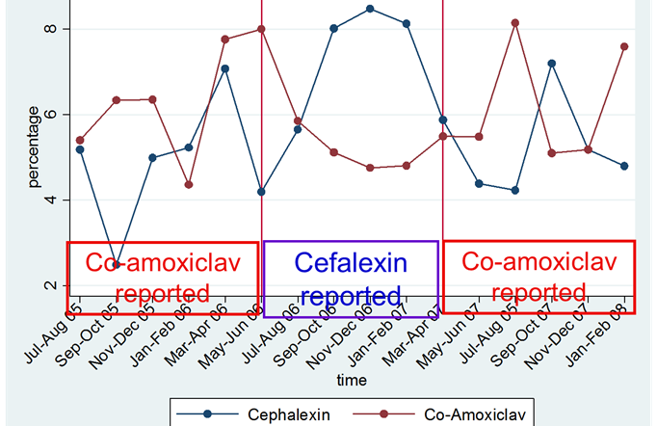

The ESPAUR report (*The English Surveillance Programme for Antimicrobial Utilisation and Resistance*1) contains data on the susceptibility of certain pathogens to key antibiotics during a four year data collection period (2010 to 2014). While previously published data on antimicrobial resistance in the UK have focussed on the national picture, this report also collates for the first time data on resistance at both regional and sub-regional levels. It is hoped that this data will inform end users about the local epidemiology and burden of antibiotic resistance and allow bench marking against regional and national trends.

# Near-patient testing and algorithms

**C-Reactive Protein (CRP) testing** - a CRP test is a blood test used to help diagnose conditions that cause inflammation. CRP tests can be used to differentiate pneumonia from other respiratory tract infections and use of these tests in some cases of acute cough is now recommended by NICE in the UK Health Security Agency (UKHSA) publication entitled A Quick Reference Implementation Tool for CCGs and Primary Care: The Management and Treatment of Common infections6.This includes clinical algorithms and near patient tests to guide antibiotic use.

A **urine test strip** or **dipstick test** is a basic [diagnostic](https://en.wikipedia.org/wiki/Medical_diagnosis) tool used to determine changes in a patient’s [urine](https://en.wikipedia.org/wiki/Urine). Urine dipsticks may reduce antibiotic use when patients present with mild urinary symptoms. For further information see <https://www.gov.uk/government/publications/urinary-tract-infection-diagnosis>.

**FeverPAIN –** FeverPAIN is a five-item score based on: Fever, Purulence, Attend rapidly (3 days or less), severely inflamed tonsils and no cough or coryza. Using FeverPAIN enables rapid calculation of a score and gives a treatment guide. For further information see: <https://ctu1.phc.ox.ac.uk/feverpain/index.php> and the TARGET Antibiotics workshop presentation.

# Conclusions

The TARGET Antibiotics Toolkit is a flexible resource that helps prescribers improve antibiotic prescribing in primary care. This guide has provided an overview for trainers and facilitators of the resources available in the Toolkit and how these can be delivered. By utilising the TARGET resources fully practitioners can:

* Make a difference to the care of individual patients
* Help to slow the development of future resistance in our community
* Help to increase patient self-care and reduce further consultations for minor infections

For further information or to feedback any comments please contact the TARGET team at [TARGETantibiotics@phe.gov.uk](mailto:TARGETantibiotics@phe.gov.uk) or by calling **Dr Cliodna McNulty** Tel: 0208 4953263

Use this link to view the TARGET Toolkit on our website:

[www.RCGP.org.uk/TARGETantibiotics/](http://www.RCGP.org.uk/TARGETantibiotics/)

# References

1. Public Health England. The English Surveillance Programme for Antimicrobial Utilisation and Resistance Report 2016. Online: <https://www.gov.uk/government/uploads/system/uploads/attachment_data/file/575626/ESPAUR_Report_2016.pdf> [Accessed 20 July 2017]
2. Department of Health. UK 5-year action plan for antimicrobial resistance 2019 to 2024. Online: <https://www.gov.uk/government/publications/uk-5-year-action-plan-for-antimicrobial-resistance-2019-to-2024> [Accessed 21 Feb 2019]
3. McNulty CAM, Lecky DM, Hawking MKD, et al. Delayed/back up antibiotic prescriptions: what do the public think? BMJ Open 2015;5:e009748.
4. NICE. Antimicrobial stewardship: systems and processes for effective antimicrobial medicine use. [NG 15], August 2015. Online: <https://www.nice.org.uk/guidance/ng15> [Accessed 20 July 2017]
5. McNulty CAM, Lasseter GM, Charlett A, Lovering A, Howell-Jones R, MacGowan A, Thomas M. Does laboratory antibiotic susceptibility reporting influence primary care prescribing in urinary tract infection and other infections? J Antimicrob Chemother 2011;66:1396-1404.
6. Public Health England. Managing common infections: guidance for primary care for consultation and adaption, 2017. Online: <https://www.gov.uk/government/publications/managing-common-infections-guidance-for-primary-care> [Accessed 20 July 2017]
7. Nice. Antimicrobial stewardship: changing risk-related behaviours in the general population. [NG 63]. January 2017. Online: <https://www.nice.org.uk/guidance/ng63>
8. NHS England. Quality Premium 2017-19. Online: <https://www.england.nhs.uk/ccg-out-tool/qual-prem/> [Accessed 20 July 2017]
9. McNulty, CAM et al., Effects of primary care antimicrobial stewardship outreach on antibiotic use by general practice staff: pragmatic randomized controlled trial of the TARGET antibiotics workshop. Journal of Antimicrobial Chemotherapy, 2018.