The Managing Your Common Infection (self-care) leaflet can be used as a tool for the public and communities to increase awareness and change behaviour around antibiotic use by increasing individuals’ confidence and knowledge on how to self-care for their own infections and subsequently reducing inappropriate antibiotic use.

What are the aims of the Managing Your Common Infection leaflet?
The leaflet aims to give information, in line with NICE 63 guidance on:
- Increase awareness and change behaviour around hygiene, self-care and subsequently antibiotic use
- The natural course of self-limiting infections
- How people can self-care
- Explicit advice when to seek medical help
- Simple advice to wash their hands to reduce the spread of infection
- Provide information on COVID-19 in line with UK Government guidance

The leaflet follows behavioural steps which help the reader to make decisions on how to manage their own infection. The behavioural steps are:

- What are the symptoms of a common infection?
- What if I think I have coronavirus (Covid-19)? 2
- How can I treat a common infection?
- How long could my infection last?
- Will my infection need antibiotics to get better?
- How can I stop my infection from spreading?
- What symptoms of serious illness should I look out for?
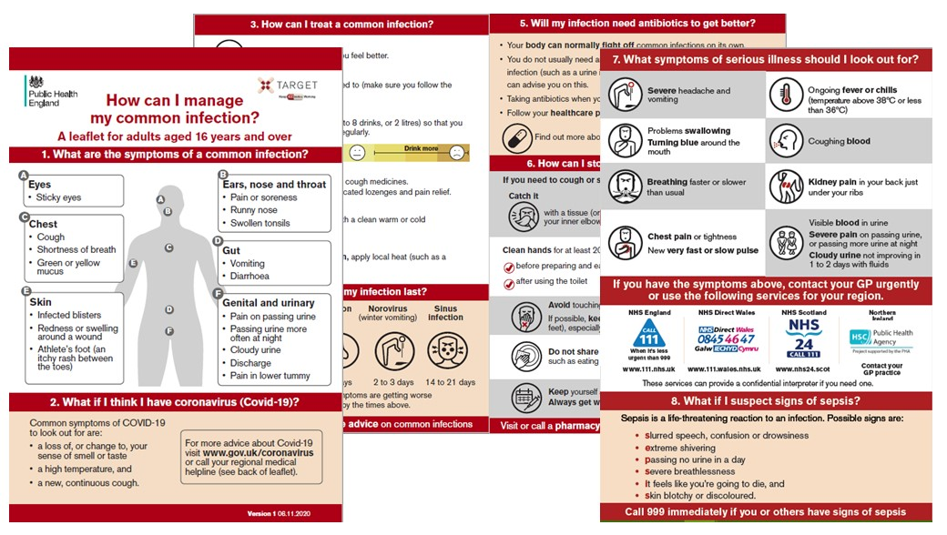
- What if I suspect signs of sepsis?

When to use the Managing Your Common Infection leaflet?
The leaflet can be used in a variety of situations and settings including in:-
- Community pharmacy to educate patients about self-care for common infections
- Consultations to share with patients
- GP surgery waiting rooms
- Community groups

Why create the Managing Your Common Infection leaflet?
TARGET currently have leaflets for respiratory tract and urinary tract infections. In some cases, such as in community pharmacy, healthcare professionals may not know what type of infection a patient has, and therefore this leaflet can provide general advice covering common infections in general. This leaflet aims to empower patients to manage symptoms of common infections through simple self-care actions and provide safety netting information including serious signs of illness to look out for and where to seek urgent help.

We are happy to receive feedback about how you have used this leaflet and any constructive comments on how it can be improved. Please contact the TARGET team via email at TARGETantibiotics@phe.gov.uk

