How can I manage my common infection?
A leaflet for adults aged 16 years and over

1. What are the symptoms of a common infection?

A

Eyes
- Sticky eyes _{A}
C B

Chest
- Cough
- Shortness of breath C
- Green or yellow E
mucus
B

Ears, nose and throat
- Pain or soreness
- Runny nose
- Swollen tonsils
D

Gut
- Vomiting
- Diarrhoea

E

Skin
- Infected blisters
- Redness or swelling around a wound
- Athlete’s foot (an itchy rash between the toes)
F

Genital and urinary
D
  - Pain on passing urine
F • Passing urine more often at night
  - Cloudy urine
  - Discharge
  - Pain in lower tummy

Version 1.1: Nov 2020
Revision: Nov 2023
TARGET is operated by the UK Health Security Agency.
Developed in collaboration with professional medical bodies.

If you think you may have COVID-19 then please visit http://www.gov.uk/coronavirus or http://www.nhs.uk for the latest guidance and information.
2. What if I think I have coronavirus (Covid-19)?

3. How can I treat a common infection?

Get plenty of rest until you feel better.

Take pain relief if you need to (make sure you follow the instructions).
Drink plenty of fluids (6 to 8 drinks, or 2 litres) so that you pass pale-coloured urine regularly.
Drink more

For coughs, try honey and cough medicines.
For sore throats, try medicated lozenges and pain relief.

Soothe eye infections with a clean warm or cold damp flannel.

For an outer ear infection, apply local heat (such as a warm flannel).

How long could my infection last?

Cough Sore throat or earache
Common cold
Norovirus
(winter vomiting)

Sinus infection

21 days 7 to 8 days 14 days 2 to 3 days 14 to 21 days
Contact your GP if your symptoms are getting worse or if you are not better by the times above.

Will my infection need antibiotics to get better?

- Your body can normally fight off common infections on its own.
- You do not usually need antibiotics, unless symptoms of a bacterial infection (such as a urine infection) are severe – a healthcare professional can advise you on this.
- Taking antibiotics when you do not need to puts you and your family at risk.

Follow your healthcare professional’s advice on antibiotics.

Find out more about antibiotics at www.antibioticguardian.com

How can I stop my infection from spreading?

If you need to cough or sneeze:

Catch it

with a tissue (or your inner elbow)

Bin it Kill it
throw away used tissues

by cleaning
your hands

Clean hands for at least 20 seconds with soap and water or hand sanitiser:

before preparing and eating food after using the toilet
after touching pets or animals when leaving and arriving home

Avoid touching your eyes, nose or mouth with unclean hands.
If possible, keep your distance from others (2 meters or 6 feet), especially vulnerable people in your household.

Do not share items that come into contact with your mouth, such as eating utensils and toothbrushes.
Visit or call a pharmacy for further advice on common infections
Keep yourself and your family up to date with vaccinations. Always get winter vaccines (such as flu) if you are eligible.

What symptoms of serious illness should I look out for?

Severe headache and vomiting

Problems swallowing
Turning blue around the mouth

Ongoing fever or chills (temperature above 38ºC or less than 36ºC)

Coughing blood

Breathing faster or slower than usual

Chest pain or tightness
New very fast or slow pulse

Kidney pain in your back just under your ribs

Visible blood in urine
Severe pain on passing urine, or passing more urine at night
Cloudy urine not improving in 1 to 2 days with fluid

If you have the symptoms above, contact your GP urgently or use the following services for your region.

NHS England NHS Direct Wales

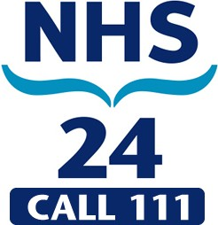
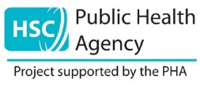
NHS Scotland Northern Ireland

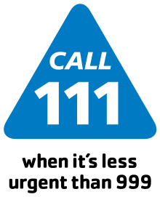
www.111.nhs.uk www.111.wales.nhs.uk www.nhs24.scot Contact your
GP practice
These services can provide a confidential interpreter if you need one.

What if I suspect signs of sepsis?
Sepsis is a life-threatening reaction to an infection. Possible signs are:
  - slurred speech, confusion or drowsiness
  - extreme shivering
  - passing no urine in a day
  - severe breathlessness
  - it feels like you’re going to die, and
  - skin blotchy or discoloured.

