

URINARY TRACT INFECTIONS
A leaflet for older adults and carers

What is a urine infection?

Speak to your pharmacist about referral to a GP
or other treatments.
What you can do to help prevent a urine infection
Drink more
- Drink enough fluid (6-8 glasses) so that you pass pale coloured urine regularly during the day, and to avoid feeling thirsty, especially during hot weather
- Avoid drinking too many fizzy drinks or alcohol
- There is no proven benefit of cranberry products or cystitis sachets
- Prevent constipation; ask for advice if needed
- Maintain good control of diabetes

Stop bacteria spreading from your bowel into your bladder:
- Wipe genitals from front to back after using the toilet
- Change pads and clean genitals if soiled
- Keep the genital area clean and dry; avoid scented soaps
- Wash genital area with water before and after sex
WHAT IS A URINE INFECTION?
A urine infection occurs when bacteria in any part of the urine system cause symptoms.

If a urine test finds bacteria but you are
otherwise well, do not worry, this is common, and antibiotics are not usually needed. However, severe urine infections can be life threatening.

Version 1.1, Published: April 2018, Revision: April 2021
WHAT YOU CAN DO TO HELP PREVENT
A URINE INFECTION?
Are you drinking enough? Look at the colour of your urine.

Kidneys make urine

Bladder stores urine

Urethra takes urine out of the body

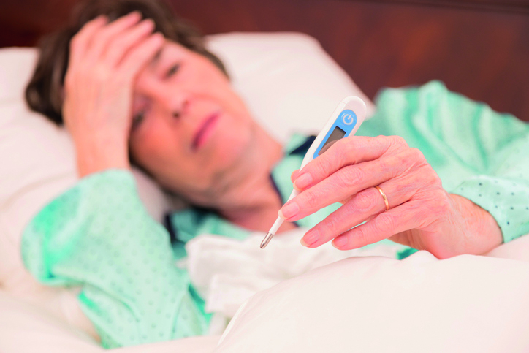
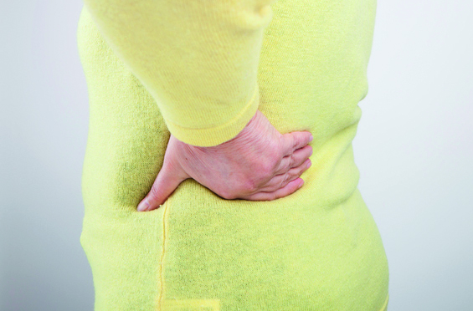
- Pain • Side effects of medicine
- Constipation • Other infection
- Poor sleep • Change in your routine or
- Low mood home environment
- Not drinking enough • Poor diet

WHAT SIGNS AND SYMPTOMS SHOULD YOU LOOK OUT FOR?

Consider these symptoms if you have a urinary catheter:
- Shivering or shaking
- High or low temperature
- Kidney pain in your back just under the ribs

New or worsening signs of urine infection in all people:
- Pain or burning when passing urine
- High or low temperature (also a sign of COVID-19 – see below)
- Shivering or shaking
- Urgency (feeling the need to urinate immediately)
- Pain in your lower tummy above pubic area
- Incontinence (wetting yourself more often than usual)
- Passing urine more often than usual
- Cloudy urine, or visible blood in your urine
- Confusion, change in behaviour, or unsteadiness on feet

CONSIDER OTHER THINGS THAT MAY ALSO CAUSE CONFUSION

ALWAYS CONSIDER COVID-19

If you think you may have COVID-19 then please visit http://www.gov.uk/coronavirus or http://www.nhs.uk for the latest guidance and information
WHAT CAN YOU DO TO HELP FEEL BETTER?

- There is no proven benefit of cranberry products or cystitis sachets
- If you’re worried about wetting yourself, see your doctor or nurse for advice
- Ask for advice from your pharmacist/carer
- Drink enough fluids to avoid feeling thirsty and to keep your urine pale
- Drink enough fluid so that you pass urine regularly during the day, especially during hot weather
- Take paracetamol regularly, up to 4 times daily to relieve fever and pain



WHAT MIGHT YOUR PHARMACIST / NURSE / DOCTOR DO?
- If your symptoms are likely to get better on their own you may receive self-care advice and pain relief
- Ask you to drink more fluids
- Ask you for a urine sample
- You may be given an antibiotic that
you can use if your symptoms don’t
improve or you start to feel worse



ADVICE ABOUT ANTIBIOTICS

- Antibiotics can be life saving for serious urine infections, but antibiotics are not always needed for all urinary symptoms
- Antibiotics may make the bacteria in your bowel resistant to antibiotics making UTIs difficult to treat in the future

- Common side effects of taking antibiotics include thrush, rashes, vomiting and diarrhoea; ask for advice if you are worried
- Keep antibiotics working, only take them when your healthcare professional advises them




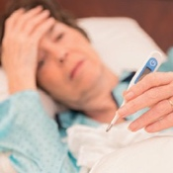


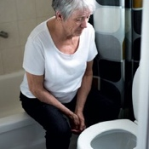

Contact your GP Practice or contact NHS 111 (England), NHS 24 (Scotland dial 111), NHS direct (Wales dial 0845 4647), or GP practice (NI)
WHEN SHOULD YOU GET HELP?
The following symptoms are possible signs of serious infection and should be assessed urgently

Feeling very confused, drowsy or slurred speech
Temperature is above 38ºC* or less than 36ºC

Kidney pain in your back just under the ribs

Very cold skin

Trust your instincts, ask for advice if you are not sure
how urgent the symptoms are.

TARGET is operated by the UK Health Security Agency.

Developed in collaboration with professional medical bodies.

Version: 2.4 Published: October 2018 Review date: June 2021

Visible blood in your urine

Trouble breathing

Not passing urine all day

Shivering, chills and muscle pain

Symptoms are getting a lot worse, or not starting to improve within 2 days of starting antibiotics.

