Rationale: Why develop a leaflet for UTIs in older frail adults?
Rates of E. coli has increased by 6.1% from 2015 – 2017, and 25.6% since 2012/13.¹ The age group with the highest rates of E. coli bacteraemia in England were observed amongst older adults¹ On-going mandatory surveillance of E. coli bacteraemia has identified 46.9% of cases were most likely due to urinary tract infections (UTIs).^{1, 2} By improving knowledge on how to prevent UTIs, how UTIs develop, are diagnosed and managed, self-care advice and advice on when to re-consult, this could reduce recurrent infections and improve older adults’ health and wellbeing.

Purpose: Patient satisfaction is more related to having a careful examination and having concerns identified and addressed than to receiving a prescription for antibiotics. This provides a great opportunity to share information with patients and reassure them. We know how busy prescribers are, and how important it is to use precious consultation time efficiently. Therefore, we have developed a leaflet to share with older adults and their relatives or carers when they have urinary symptoms or with those who may be at risk of future UTIs.

Additionally, from 2020, information about COVID-19 in line with UK Government guidance is included.

Overview of the TYI-UTI leaflet

Development: The leaflet has been developed following extensive needs assessment with general practitioners, care home staff, care home residents and their relatives, and a variety of stakeholders. The older adult leaflet was developed based on the original TARGET UTI leaflet for uncomplicated UTIs, and underwent iterative modifications after each interview or focus group. Data collection was informed by the Theoretical Domains Framework in order to explore all behavioural determinants.³
Use: The leaflet can be used in several ways. To provide information on UTIs to those at risk, care staff may wish to share this leaflet with older adults in their care and/or their relatives. The leaflet may also be used during primary care consultations to facilitate dialogue between a patient and their GP on specific topics like treatment or safety netting.
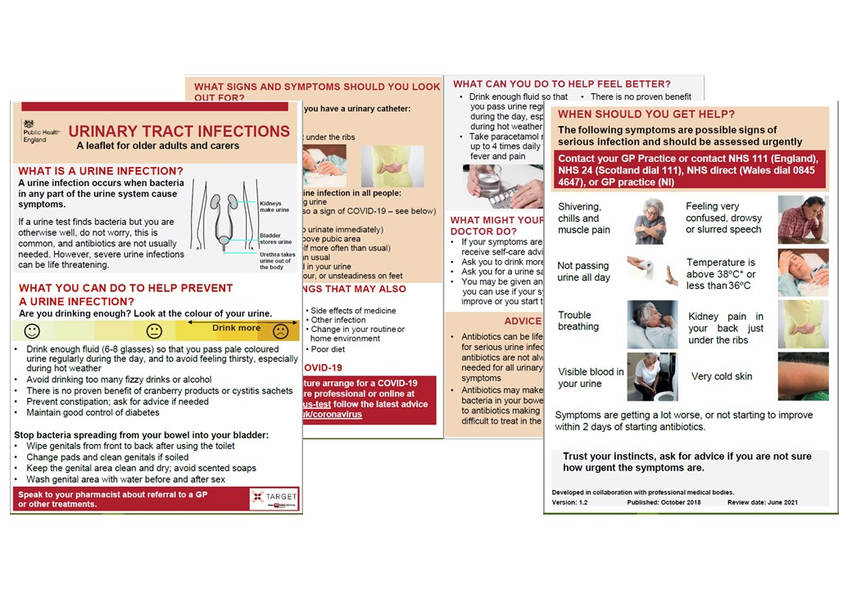
It is important that the leaflet is used as a tool to interact with patients, rather than as a ‘parting gift’. In order to do this effectively you should be familiar with its content.

We are happy to receive feedback about how you have used this leaflet and any constructive comments on how it can be improved. Please contact the TARGET team via email at TARGETantibiotics@phe.gov.uk.

1. Public Health England. Annual Epidemiological Commentary: Mandatory MRSA, MSSA and E. coli bacteraemia and C. difficile infection data 2016/17. 2017.
2. Public Health England. Health Protection Report; Infection Report. 2016 17th June 2016.
3. Cane J, O’Connor D, Michie S. Validation of the theoretical domains framework for use in behaviour change and implementation research. Implementation Science. 2012;7(37).

