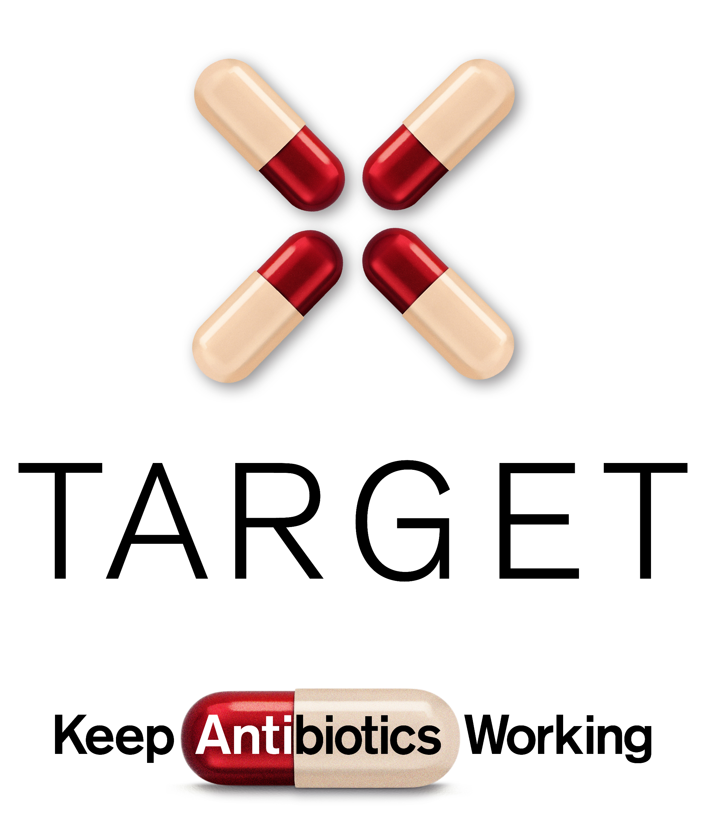
TARGET TYI-RTI Pictorial Leaflet
A step-by-step guide on how to manage your infection
User Guide

Sharing of leaflets with patients presenting with respiratory tract infections significantly reduce inappropriate antibiotic prescribing. The Managing Your Infection leaflet can be used as a tool for the public and communities to increase awareness and change behaviour around antibiotic use by increasing individuals’ confidence and knowledge on how to self-care for their own infections and subsequently reducing inappropriate antibiotic use.

What are the aims of the Managing Your Infection pictorial leaflet?
The leaflet aims to very simply give information, in line with NICE 63 guidance on:
- Increase awareness and change behaviour around hygiene, self-care and subsequently antibiotic use
- The natural course of self-limiting infections
- How people can self-care
- Explicit advice when to seek medical help
- Simple advice to wash their hands to reduce the spread of infection

The leaflet has four main behavioural steps which help the reader to make decisions on how to manage their own infection. The behavioural steps are:

- How to help make yourself better
- Check how long your symptoms last
- Look out for serious symptoms
- Where to get help

When to use the Managing Your Infection pictorial leaflet?
The leaflet can be used in a variety of situations and settings including in:-
- Consultations to share with patients
- GP surgery waiting rooms
- Community groups in antibiotic related activities

Why create the Managing Your Infection pictorial leaflet?
70% of antibiotics are prescribed in the community and more than 50% are unnecessary. Therefore sharing leaflets with patients presenting with RTI’s significantly reduces their inappropriate use of antibiotics.

Community groups, including adults with learning difficulties, can find the current self-care leaflets overwhelming due to the amount of text. The Primary Care Unit at Public Health England (PHE) have therefore developed a pictorial self-care leaflet based on the TARGET Treating Your Infection Respiratory Tract Infection (RTI) Leaflet. The leaflet is pictorial based and is awarded the Crystal Mark for use of plain English so that it is suitable for a range of community groups including adults with learning difficulties, young mothers and younger audiences like girl guiding and youth groups.

We are happy to receive feedback about how you have used this leaflet and any constructive comments on how it can be improved. Please contact the TARGET team via email at TARGETantibiotics@phe.gov.uk

