

Respiratory

tract infections (RTIs)

**A step-by-step guide on how**

**to manage your infection**

# What is an RTI?

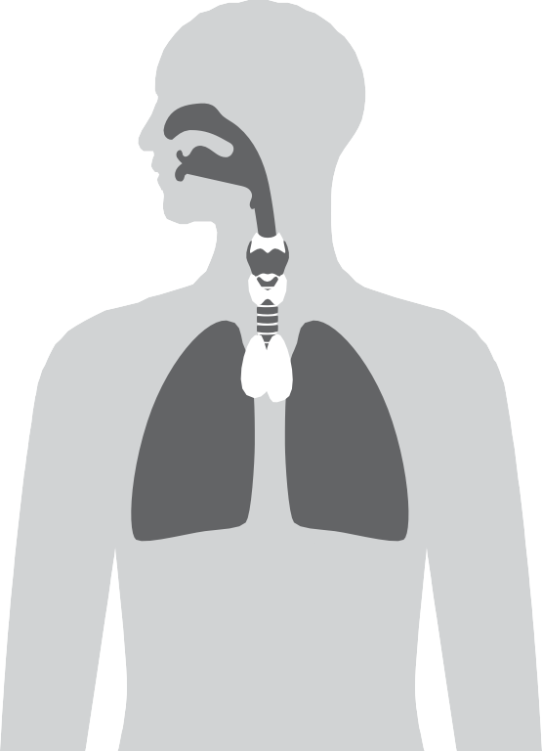

A respiratory tract infection (RTI) occurs in the upper or lower respiratory tract, causing symptoms. A RTI is usually caused by a virus, but can sometimes

be bacterial.

**What are some common symptoms of an RTI?**

**Nasal cavity**

* Blocked or runny nose

**Sinuses**

* Pain
* Swelling

**Lungs**

* Cough
* Shortness of breath
* Coughing up mucus

**Ears**

* Earache

**Throat**

* Sore throat
* Swollen tonsils

Version 4.0. Published: November 2024. Revision date: November 2027. This leaflet has been developed with healthcare professionals, patients and professional medical bodies. TARGET is operated by the UK Health Security Agency.

# Help yourself to feel better

**1**

**Whatever your infection, you can do the following to help.**

Take paracetamol to reduce pain. Always follow the instructions on the packet.

Ask your pharmacist for advice

on reducing your symptoms.

Get plenty of rest until you

feel better.

Drink enough fluids to avoid feeling thirsty.

Use tissues when you sneeze to help stop infections spreading.

Wash your hands regularly

and after using tissues.

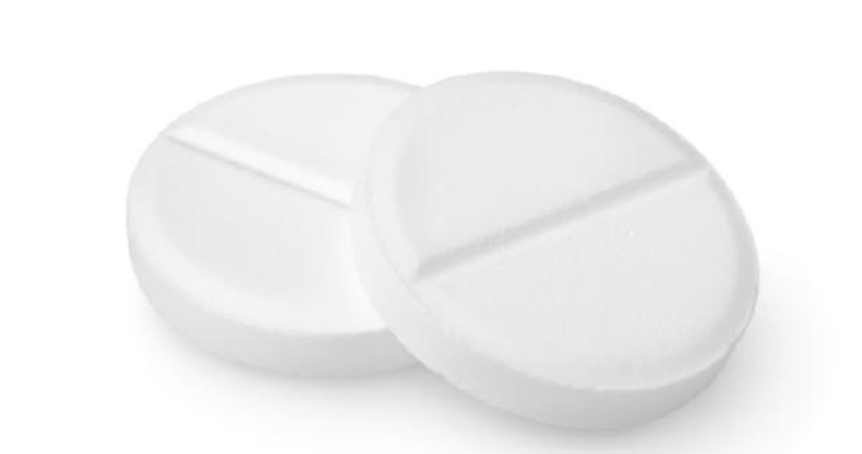

For more information, visit the NHS website at [**www.nhs.uk**.](http://www.nhs.uk/) Most common infections get better without antibiotics. Find out how you can make better use of antibiotics at [**www.antibioticguardian.com**.](http://www.antibioticguardian.com/)

# Check how long your symptoms last



**2**

**Earache**

Most get better by **7 to 8 days**

**Sore throat**

Most get better by **7 to 8 days**

**Cold**

Most get better by **14 days**

**Cough**

Most get better by **3 to 4 weeks**

If you are not starting to improve a little by the times given above, visit a pharmacist or contact your GP practice. If you are feeling a lot worse, phone **NHS 111** or **NHS 24** (see step 4).

# Look out for serious symptoms

**3**

If you have an infection and develop any of the symptoms below, **you should see a doctor urgently**. Ring your **GP practice** or call **NHS 111** or **NHS 24**.

**Severe headache**

**Very cold skin**

**Trouble breathing**

**Feeling confused**

**Chest pain**

**Problems swallowing**

**Coughing blood**

**Feeling a**

**lot worse**

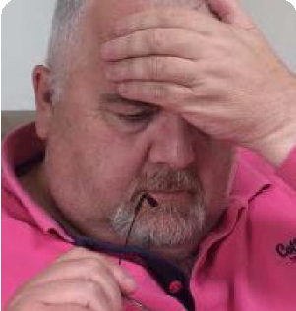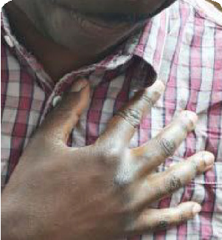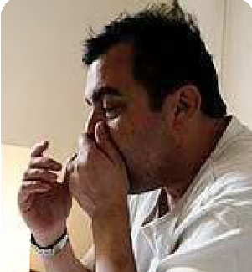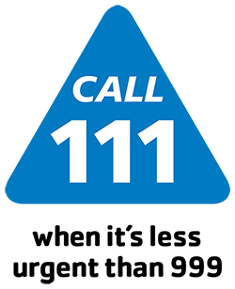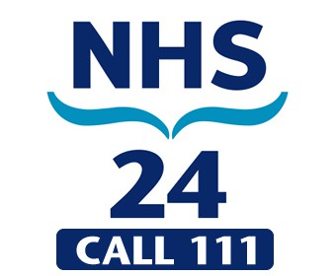

**NHS England**

**NHS 111**

**Wales**

**NHS Scotland**

**Northern**

**Ireland**

**Contact your**

**GP practice**

**4 Where to get help**

If you have an **emergency**, call 999 immediately