Aim
To evaluate the diagnosis and management of catheter associated urinary tract infections in people of all ages.
Audit criteria are based on Public Health England (PHE) and NICE guidance and tools.

How to use this audit
Step 1: Familiarise yourself with the diagnosis and management for UTI guidance by reviewing:
Diagnostic flowchart figure 1: Flowchart for suspected UTI in catheterised adults or those over 65 years [PHE Quick reference tool for primary care], to assess your practice’s or your individual compliance with the recommended algorithm. See the website for more information and the rationale behind the diagnostic recommendations.
NICE/PHE Catheter associated UTI antimicrobial prescribing guideline Tables 1 and 2: NICE UTI (Catheter) antimicrobial prescribing visual summary for choice of antibiotic, to determine the proportion of your patients who have been prescribed the recommended antibiotics, including dose, frequency and duration. You can visit the NICE website for more information and the rationale behind the recommendations.
You may wish to use your local primary care organisation’s guidance as an alternative.
Please view the TARGET older adult UTI leaflet and the TARGET uncomplicated UTI leaflet for self-care safety netting and other advice to share during the consultation or with the patient or carers.
Urinary prophylaxis: Do not routinely offer antibiotic prophylaxis to people with a short-term or long-term catheter [NG113].
COVID-19: Be aware that from March 2020 onwards, practice will have considerably increased numbers of remote consultation to limit patient and healthcare worker exposure to COVID-19. It is assumed that COVID-19 will have been excluded as a likely cause for high temperature.

Step 2: Search for all patients with urinary catheters.
Develop a Register
Obtain a list of people with indwelling urinary catheters in your practice.
If this is not readily available: the list can be developed by cross-referencing:
- people prescribed catheter items (via practice or medicines management teams, depending on local supply arrangements)
- district nurse database printout OR
- from continence teams
Confirm that the person still has an indwelling urinary catheter or self-catheterises.
Code all patients on the register, for example in the problem list or significant medical history, so that they are readily identifiable when presenting with symptoms, for example, 8D74 Indwelling urethral catheter.
If no longer catheterised, consider adding, 7B2B2 removal of urethral catheter.

Step 3: For each patient with a urinary catheter undertake a notes search and audit episodes of suspected urinary tract infection in the last 3 - 6 months. Maximum 20 episodes in total. If there are more than 3 episodes for one patient, audit the latest 3 episodes. Consider recording in the ‘notes’ column, the initial reason why a UTI is suspected and which led to contact with the practice. This will help identify appropriate and inappropriate reasons which can be discussed by the wider primary care team if needed.

Figure 1: Flowchart for suspected UTI in catheterised adults or those over 65 years
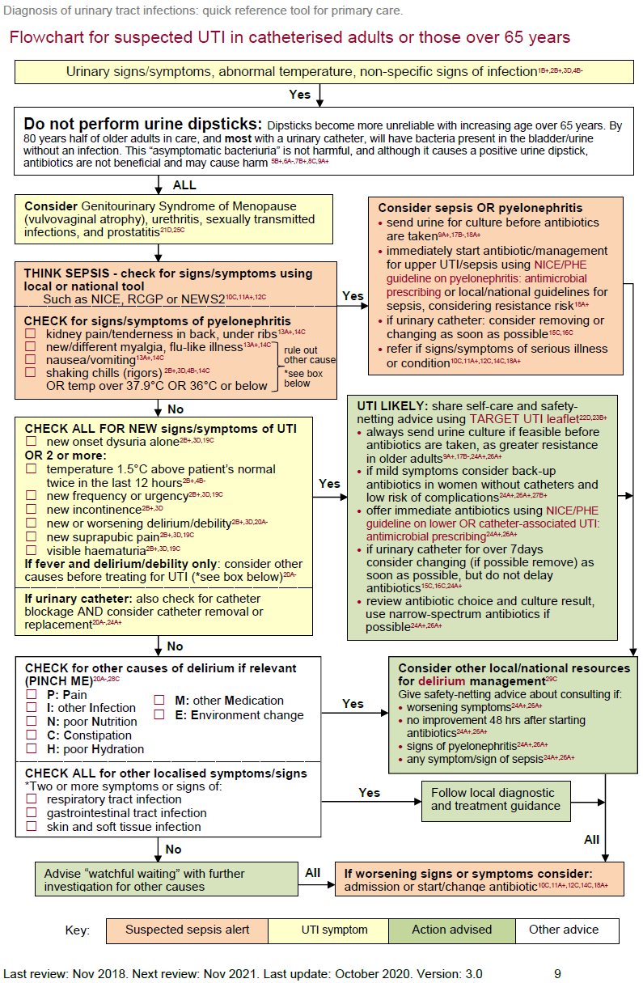
Table 1: UTI (catheter): antimicrobial prescribing
Choice of antibiotic: non-pregnant women and men aged 16 years and over; NICE/PHE Guidance

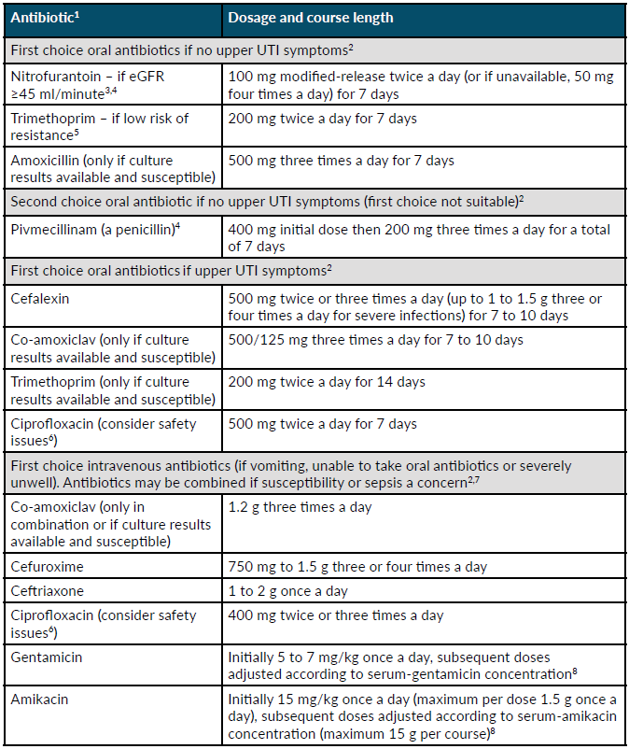
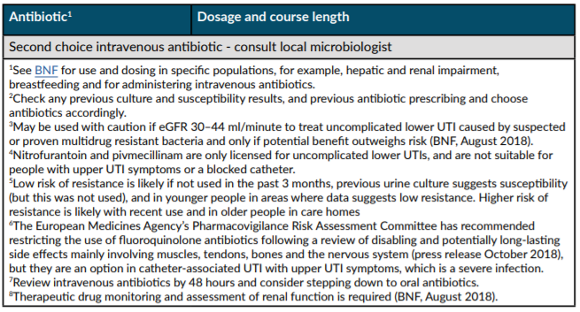

Step 4: Compete the data collection table below for your practice and each selected patient.
- Number of consultations used in audit: _______
- Practice population: ______
- Total number patients with indwelling urinary catheters: _____
- Rate of indwelling urinary catheterisation _____________
- Number people with indwelling catheters, without contact query infection in the last 6 months: ______(these will not be included in the audit)
- Number of people with indwelling catheter on prophylactic antibiotics to prevent CAUTI: ______
COVID-19: It is assumed that COVID-19 will have been excluded as likely cause for high temperature

Main results table (NOTE: complete the table using the numbers 1 and 0 where yes=1, no=0)
Patients in audit consulting with suspected UTI, WITH URINARY CATHETER
complete the table using the numbers 1 and 0 where yes=1, no=0
Compliance with PHE Guidance for Management of UTI in >65s and NICE antibiotic UTI (catheter), antimicrobial prescribing guidance |  |  | 1 |  | 2 |  | 3 |  | 4 |  | 5 |  | 6 |  | 7 |  | 8 |  | 9 |  | 10 |  | 11 |  | 12 |  | 13 |  | 14 |  | 15 |  | 16 |  | 17 |  | 18 |  | 19 |  | 20 |  | Number of patients (N) |  | % of Total with UTI |  | Your target % for good practice |  | Notes
Patient ID
Diagnostic decision
A | Telephone/Surgery/Visit
B | Initials or role of consulting clinician
C | Catheter coded in notes (Snomed or read-code)
D | Clear documentation that urinary catheter appropriate
E | Date of suspected UTI episode
F | Dipstick used? Enter 0 if no, 1 yes
G | Features of pyelonephritis assessed and recorded e.g. Flank pain/under ribs, new myalgia, nausea, vomiting, shaking/chills or temp >37.9 or <36
H | Features of pyelonephritis or sepsis present
I | If features of pyelonephritis or sepsis present, was severity of sepsis assessed? Temperature, heart rate, respiratory rate, blood pressure, level of consciousness and oxygen saturation [NICE NG51 sepsis] (N/A = 3)
J | Other causes of signs/symptoms assessed e.g. RTI, GIT or skin infection and PINCH ME
K | If no sepsis or pyelonephritis; were UTI diagnostic criteria assessed i.e.  Two or more [PHE UTI flowchart]:  •temperature ≥1.5 C above normal  •suprapubic pain  •haematuria  •delirium
L | If antibiotic given and catheter in place for >7days was it removed or replaced? (N/A = 3)
M | Urine sent for culture (reminder- label as CAUTI)
N | Patient on antibiotic prophylaxis to prevent CAUTI (at time of episode)
Management decision / treatment
O | Antibiotic given
P | Management decision meets guidelines
Advice given to patient
Q | Information about when to re-consult  safety netting advice
R | Shared the TARGET UTI leaflet for older adults(this occasion or last 12 months)
If antibiotics were prescribed was the…
S | Antibiotic choice in line with NG113 i.e.  a. Lower UTI  i. nitrofurantoin eGFR ≥45 ml/minute  ii. trimethoprim (if low risk of resistance)  iii. amoxicillin (culture results available & susceptible)  iv. Pivemecillinam (no penicillin allergy)  b. Upper UTI  i. cefalexin  ii. co-amoxiclav (culture results were available and susceptible)  iii. trimethoprim (culture results were available and susceptible)  iv. Ciprofloxacin
T | Dose/frequency/ course length all correct (doses for adults)  a. Lower UTI  i. nitrofurantoin 100mg MR BD (or 50mg QDS) 7 days  ii. trimethoprim 200mg BD 7 days  iii. amoxicillin 500mg TDS 7 days  iv. pivemecillinam 400mg stat then 200mg TDS 7 days  b. Upper UTI  i. cefalexin 500mg BD -TDS 7 - 10 days- (higher dose can be used if severe – add note if used)  ii. co-amoxiclav 625mg TDS 7 - 10 days  iii. trimethoprim 200mg BD14 days  iv. ciprofloxacin 500mg BD 7 days
U | Notes (to support practice discussion)  e.g. Patient factors of note, reason antibiotic choice did not meet guidelines

Step 5: Summary of compliance and action planning
For ease of use you can summarise your data in the Summary table below.
- Rate of indwelling urinary catheterisation = ______%
- Dipstick used to inform treatment decision for those with indwelling catheters = _____% (Target 0%)
- Features of pyelonephritis:
(i) assessed = _______% (Target 100%) (ii) Features of pyelonephritis present = _____%
- Sepsis criteria recorded of people with pyelonephritis or sepsis = _____% (Target 100%)
- Episodes where other causes excluded = _____% (Target 100%)
- If indwelling catheter in place for >7 days was it removed or replaced? = _____% (Target 100%)
- Urine sent for culture when antibiotics given ) =____% (Target 100%)
- If antibiotics used, percentage given correct antibiotic, dose/frequency, duration = ____% (Target 100%)
- People on prophylactic antibiotics to prevent CAUTI ) = _____%
- Management decision meets guidelines = _____% (Target 100%)
What can you do to improve guidance compliance?
The 3 criteria we had the best compliance with are: | The 3 criteria which are priority areas for discussion:
1. | 1.
2. | 2.
3. | 3.
The 3 most common reasons for patient contact:
1.
2.
3.
Reflection: How will I maintain our good compliance? | Reflection: How will I improve our low compliance?
Tips to share with other practices and clinicians: ______________________________________________
Things that other clinicians and evidence indicate that they should help are:
- Agree a diagnostic and treatment target and repeat the audit of selected criteria after 1 - 3 months
Tools that could help you:
- Promote use of PHE or local antimicrobial/management of infection guidelines in practice
- Encourage use of TARGET Treating Your Infection – Urinary Tract infection (TYI-UTI) leaflet for older adults by putting onto your clinical system and setting up prompt to increase accessibility
- Share the TARGET TYI-UTI leaflet with patients to support self-care and safety netting
- Promote and conduct TARGET webinars and eModules to increase staff knowledge, skills and motivation
Re-audit in ____ months, identify a date when you will repeat the audit ( ___ / ___ / ___ )

