Aim
To evaluate the diagnosis and management of uncomplicated urinary tract infections (UTI) in women under 65 years.
Audit criteria are based on Public Health England (PHE) and NICE guidance and tools.

How to use this audit
Step 1: Familiarise yourself with the diagnostic and management for UTI guidance by reviewing:

Diagnostic guidance figure 1: Flow chart for women (under 65 years) with suspected UTI [ PHE Quick reference tool for primary care] to reflect on your practice’s or your individual compliance with the recommended algorithm. You can visit the website for more information and rationale: https://assets.publishing.service.gov.uk/government/uploads/system/uploads/attachment_data/file/829721/Diagnosis_of_urinary_tract_infections_UTI_diagnostic_flowchart.pdf

NICE/PHE UTI (lower): antimicrobial prescribing guideline Table 1: Covering choice of antibiotic in non-pregnant women aged 16 years and over. The table will help you determine if each patient in your audit has been prescribed the recommended antibiotics, including dose, frequency and duration. You can visit the website for more information and the rationale: https://www.nice.org.uk/guidance/ng109

If there are symptoms of pyelonephritis or the person has a complicated UTI (associated with a structural or functional abnormality, or underlying disease, which increases the risk of a more serious outcome or treatment failure), see the recommendations on choice of antibiotic in the NICE antimicrobial prescribing guideline on acute pyelonephritis.

You may wish to use your local primary care organisation’s guidance as an alternative.

Please view the TARGET treating Your Infection UTI (TYI-UTI) leaflet for self-care safety netting and other patient advice to share during the consultation.

COVID-19: Be aware that from March 2020 onwards, practice will have considerably increased numbers of remote consultation to limit patient and healthcare worker exposure to COVID-19. It is assumed that COVID-19 will have been excluded as a likely cause for high temperature.

Step 2: Search for 10-30 consultations relating to suspected UTI in adult women (under 65 years) Exclude people who are pregnant, have catheters, a structural urological abnormality or recurrent UTI (2 UTIs in the last 6 months or 3 episodes in the last year). Use a minimum of 10 consultations, plus 1 consultation for every 1k patients if practice size is above 10k; maximum 30 consultations e.g. 15k list size = 15 consultations.
The Read codes below are a sample of codes that can be used but consider adding codes that you or your colleagues are likely to use when assessing patients with suspected UTIs. Searching for just a few codes that you usually use may identify all the consultations you require for the audit. Additionally, if you know that coding is inconsistent, you may wish to search for patients who have been prescribed a UTI antibiotic that includes trimethoprim, nitrofurantoin, pivmecillinam, fosfomycin, in the previous 1 month (Extend the time period if necessary). You may need to add ciprofloxacin, cefalexin and co-amoxiclav if these are used for UTI in your practice.
K15 | Cystitis
K190 | Urinary tract Infection
1J4 | Suspected UTI
K190z | UTI, site not specified NOS

Figure 1: Flowchart for women (under 65 years) with suspected UTI
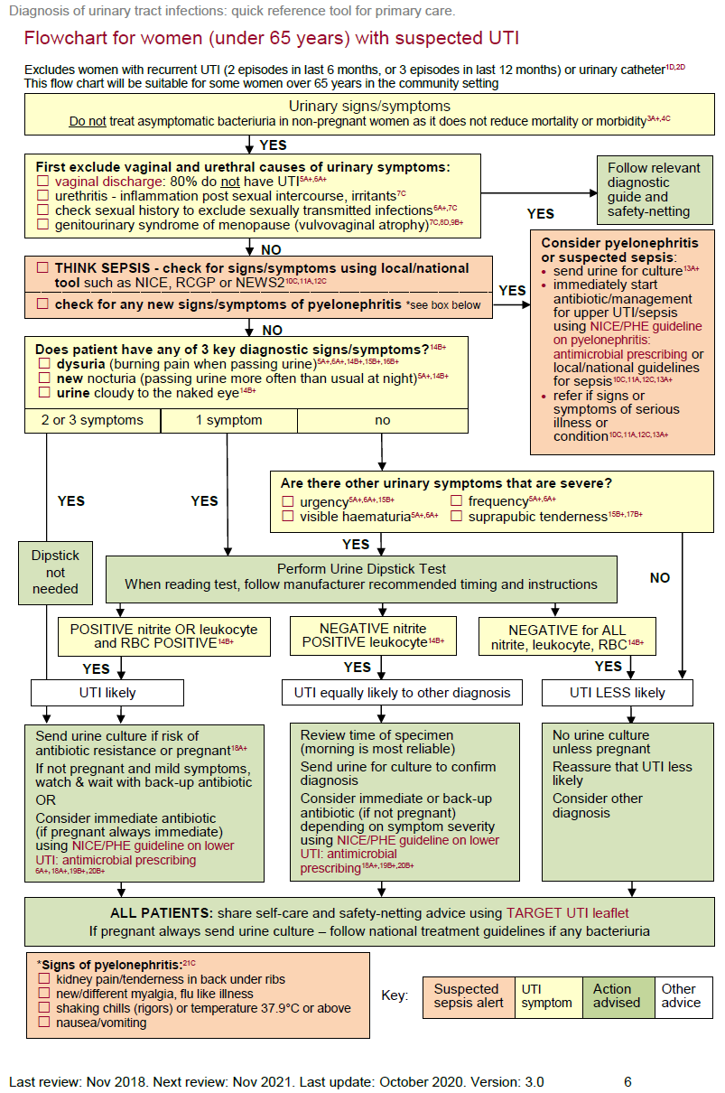
Table 1: Choice of antibiotic: non-pregnant women aged 16 years and over; NICE/PHE Guidance

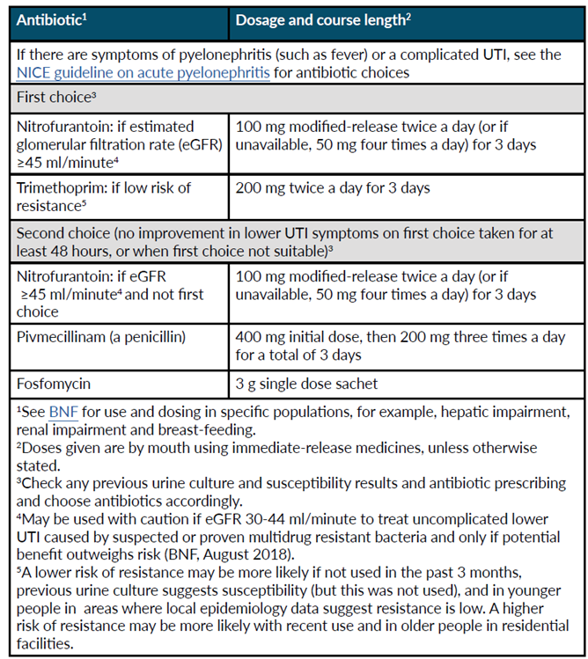

Step 3: Compete the data collection table below for each selected patient.
COVID-19: It is assumed that COVID-19 will have been excluded as likely cause for high temperature.
Main results table (NOTE: complete the table using the numbers 1 and 0 where yes=1, no=0)
Patients in audit consulting with UNCOMPLICATED UTI
complete the table using the numbers 1 and 0 where yes=1, no=0
Compliance with PHE Guidance for Management of  UNCOMPLICATED UTI |  | 1 | 2 | 3 | 4 | 5 | 6 | 7 | 8 | 9 | 10 | 11 | 12 | 13 | 14 | 15 |  | 16 |  | 17 |  | 18 |  | 19 |  | 20 |  | 21 |  | 22 |  | 23 |  | 24 |  | 25 |  | 26 |  | 27 |  | 28 |  | 29 |  | 30 |  | Number of patients (N) | % of Total with Uncomplicated UTI | Your target % for good practice
Patient ID
Evidence of Diagnostic decision
A | Optional – add clinician initials or role
B | Vaginal/urethral cause excluded e.g. notes mention absence of discharge, vulvovaginal atrophy, STI or urethritis
C | Sepsis considered (e.g. notes contain mention of temperature, heart rate, respiratory rate or BP).
D | Pyelonephritis considered (e.g. notes mention absence of fever, chills, flank pain/tenderness)
E | Sepsis or Pyelonephritis present
F | Lower UTI diagnosis in line with National guidance: e.g. PHE:  Patient has 2 or 3 diagnostic symptoms/signs (dysuria/new nocturia/cloudy urine)  OR 1 diagnostic sign AND positive dipstick (nitrite positive or leukocytes AND RBC positive)  OR other severe urinary symptoms AND positive dipstick (nitrite positive or leukocytes AND RBC positive)
G | Culture sent e.g. if risk of resistance, pyelonephritis suspected, diagnostic uncertainty
H | No antibiotic given
I | Back-up/delayed antibiotic given with advice about how to access
J | Immediate antibiotic given
K | Patients given treatment according to Guideline
L | Those patients where an antibiotic was given but an MSU was negative
M | Self-care advice given about managing symptoms including fever
N | safety netting advice given about when to re-consult
O | Shared the TARGET Treating Your Infection UTI leaflet (or similar leaflet)
Compliance with guidance to give advice?
If antibiotics were prescribed for lower UTI was the…
P | Antibiotic choice correct:  1st line: Nitrofurantoin eGFR ≥45 ml/minute  or Trimethoprim (If low risk of resistance)  2nd line: Nitrofurantoin (if not first line), Pivmecillinam and Fosfomycin  Consider adding or Trimethoprim (If low risk of resistance-e.g. not used in last 3months)
Q | Dose/frequency correct:  Nitrofurantoin 100mg m/r BD OR 50mg i/r QDS  Trimethoprim 200mg BD; or 2nd line in women: Pivmecillinam 400mg stat then 200mg tds; fosfomycin 3g single dose
R | Course length correct:  Women: 3 days (not if complicated i.e. male, pregnancy, recurrent UTI or pyelonephritis) 1 day for fosfomycin
S | NOTES

Step 4: Summary of compliance and action planning

Overall compliance with NICE / PHE Guidance
- Vaginal/urethral cause excluded = ____%
- Sepsis/pyelonephritis considered = ____%
- No antibiotic given appropriately (H + K) = ____%
- Immediate antibiotic given (J + K) = __%
- Self-care advice given about managing symptoms including fever = __%
- Safety netting advice given about when to re-consult = ____%
- TARGET Treating Your Infection UTI leaflet (or similar leaflet) shared with patient = ____%
- Were antibiotics prescribed = ____%
- Antibiotic choice correct = ____%
- Dose/frequency correct = ____%
- Course length correct = ___%
Other points of note for discussion: ________________________________________________________
What can you do to improve guidance compliance?
Reflect on your performance and complete the questions below.
The 3 criteria we had the best compliance with are: | The 3 criteria which are priority areas for discussion are:
1. | 1.
2. | 2.
3. | 3.
Reflection: How will I maintain our good compliance? | Reflection: How will I improve our low compliance?

Tips to share with other practices and clinicians: ______________________________________________
Things that might help are:
1. Agree a diagnostic and treatment target and re-audit in 1 - 3 months
Things that could help you:
1. Promote use of PHE or local antimicrobial/management of infection guidelines in practice
2. Encourage use of TARGET Treating Your Infection – Urinary Tract infection (TYI-UTI) leaflet
3. Share TARGET TYI-UTI leaflet on clinical system
4. Promote and conduct TARGET webinars, quiz and eModules
Re-audit in ____ months - identify a date when you will repeat the audit (___ / ___ / ___)

