TARGET Treating Your Infection
Urinary Tract Infection (TYI-UTI) Leaflet
User Guide

Why develop a leaflet for UTIs?
Mandatory surveillance has indicated an alarming rise in rates of E.coli bacteraemia, from 60.4 to 66.2 per 100,000 population, between 2012 and 2015. Gram-negative species are now also becoming a clinical reality for GP staff, due to the difficulties in treatment associated with the limited number of effective oral antibiotics in antibiotic-resistant UTIs. This is leading to increasing treatment failures, and a rise in E.coli bacteraemias. Women that experience recurrent episodes (3 in the past 12 months) are more likely to present with an antibiotic resistant infection. By improving self-care, this could reduce recurrent infections and improve the women’s health and wellbeing.

Patient satisfaction is more related to having a careful examination and having concerns identified and addressed than to receiving a prescription for antibiotics. This provides a great opportunity to share information with patients and reassure them. We know how busy prescribers are, and how important it is to use precious consultation time efficiently. Therefore, we have developed a leaflet to share with patients presenting with urinary symptoms suggesting a non-complicated UTI.

Overview of the TYI-UTI leaflet
The leaflet is designed to be used during consultation to facilitate dialogue between the patient and the GP, it is important that it is used as a tool to interact with patients, rather than as a ‘parting gift’. In order to do this effectively you should be familiar with its content.
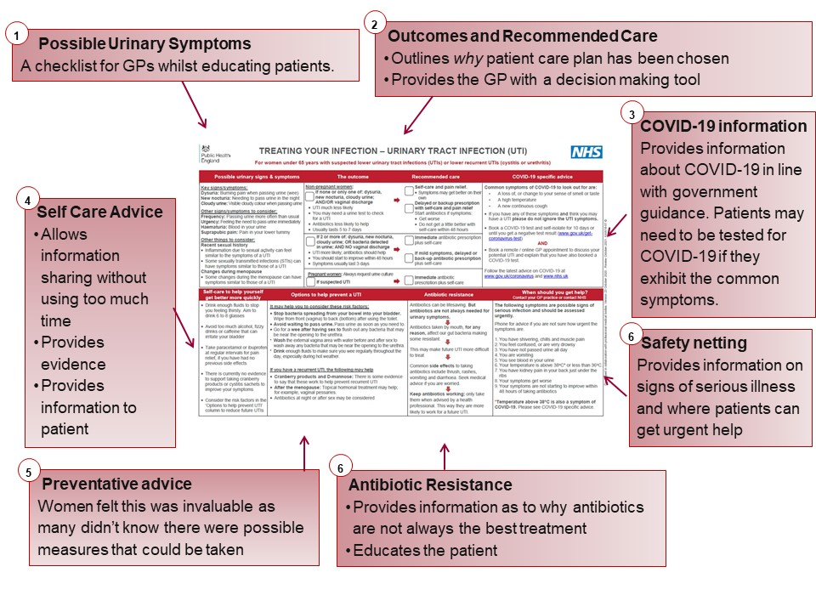
Additionally, from 2020, information about COVID-19 in line with UK Government guidance is included.

We are happy to receive feedback about how you have used this leaflet and any constructive comments on how it can be improved. Please contact the TARGET team via email at TARGETantibiotics@phe.gov.uk.

