**Treating your**

Urinary tract infection (UTI)

**For women under 65 years with suspected lower urinary tract infections (UTIs) or lower recurrent UTIs (cystitis or urethritis)**

**Patients name** (optional): Click or tap here to enter text.

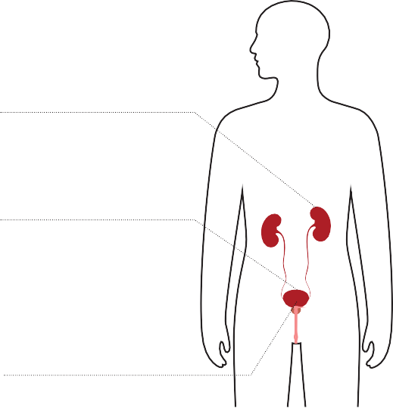

TARGET is operated by the UK Health Security Agency. This leaflet has been developed with healthcare professionals, patients and professional medical bodies. Version 24.0. Published: November 2024, Review: November 2027. KAW18-07 © Crown copyright 2024.

**Types of urinary tract infection**

UTIs are caused by bacteria getting into your urethra or bladder, usually from your gut. Infections may occur in different parts of the urinary tract.

**Kidneys (make urine)**

Infection in the upper urinary tract – pyelonephritis

(pie-lo-nef-right-is)

**Bladder (stores urine)**

Infection in the lower urinary tract – cystitis

(sis-tight-is)

**Urethra (takes urine out of the body)**

Infection or inflammation in the urethra – urethritis (your-ith-right-is)

**Self-care to help yourself get better more quickly**

* Drink enough fluids to stop you feeling thirsty. Aim to drink 6 to 8 glasses a day.
* Avoid too much alcohol, fizzy drink or caffeine as these can irritate your bladder.
* Take paracetamol or ibuprofen as advised for pain relief, if you have had no previous side effects.
* You could try taking cranberry capsules or cystitis sachets. Some women find these effective. The evidence to support their use is inconclusive.
* Consider the risk factors in the ‘Options to help prevent a UTI’ section to reduce future UTIs.

**When should you get help?**

**Contact your GP practice or NHS 111**

**The following symptoms are possible signs of serious infection and should be assessed urgently. Phone for advice if you are not sure how urgent the symptoms are.**

* You have shivering, chills and muscle pain.
* You feel confused, or are very drowsy.
* You have not been for a pee all day.
* You are vomiting.
* You see blood in your urine.
* Your temperature is above 38°C or less than 36°C.
* You have kidney pain in your back just under the ribs.
* Your symptoms get worse.
* Your symptoms are not starting to improve within 48 hours of taking antibiotics.

**Antibiotic resistance**

* Antibiotics can be life-saving, but they are not always needed for urinary symptoms.
* Taking any antibiotics can make bacteria that live inside your body more resistant. This means that antibiotics may not work when you really need them.
* Common side effects of taking antibiotics include thrush, rashes, nausea, vomiting and diarrhoea. Get medical advice if you are worried.
* Keep antibiotics working – only take them when advised by a health professional. This way they are more likely to work for a future UTI.

**Options to help prevent a UTI**

**It may help you to consider the following risk factors.**

* Stop bacteria spreading from your bowel into your bladder. Wipe from front (vagina) to back (bottom) after using the toilet.
* Avoid waiting to go to the toilet. Pee as soon as you need to.
* Go for a pee after having sex to flush out any bacteria that may be near the opening to the urethra.
* Wash the external vaginal area with water before and after sex to wash away any bacteria that may be near the opening to the urethra.
* Drink enough fluids to make sure you pee regularly throughout the day, especially during hot weather.

**If you have repeated UTIs, discuss this with a healthcare professional. The following may help.**

* There is good evidence to show that **vaginal hormonal treatment** may help after the menopause.
* You could try taking **cranberry products**, **D-mannose** or **probiotics**. Some women find these effective. The evidence to support their use is inconclusive.

**Immediate treatment with antibiotics,** plus self-care.

**If you are pregnant**

**Always ask for a urine culture test if a UTI is suspected.**

**Recommended care**

# Self-care and pain relief

* Symptoms may get better on their own.

**Delayed or backup prescription with self-care and pain relief**

Start antibiotics if your symptoms:

* get worse, or do not get a little better with self-care within 48 hours.

**Immediate** treatment with antibiotics, plus self-care.

# If your symptoms are mild, start delayed or backup treatment with antibiotics, plus self-care.

**The outcome**

**If you are not pregnant**

**If you have none, or only one of, dysuria, new nocturia or cloudy urine, or you have a vaginal discharge (on its own or with any of the above):**

* + a UTI is much less likely
  + you may need a urine test to check for a UTI
  + antibiotics are less likely to help, and
  + the infection will usually last 5 to 7 days.

# If you have 2 or more of dysuria, new nocturia, cloudy urine or bacteria in your urine and no vaginal discharge:

* + a UTI is more likely and antibiotics should help
  + you should start to improve within 48 hours, and
  + symptoms usually last 3 days.

**Possible urinary signs and symptoms**

**Key signs and symptoms**

* **Dysuria:** Burning pain when peeing
* **New nocturia:** Needing to pee in the night
* **Cloudy urine:** Pee looks cloudy

# Other signs and symptoms to consider

* **Frequency:** Peeing more often than usual
* **Urgency:** Feeling the need to pee immediately
* **Haematuria:** Blood in your urine
* **Suprapubic pain:** Pain in your lower tummy

# Other things to consider

# Recent sex

* Inflammation due to sex can

feel similar to the symptoms of a UTI.

* Some sexually transmitted infections (STIs) can have symptoms similar to those of a UTI.

# Changes during menopause

* Some changes during the menopause can have symptoms similar to those of a UTI.