Rationale: Why develop a combined leaflet for adults?
This leaflet contains information from the TARGET TYI-UTI leaflet for women under 65 years and TYI-UTI leaflet for older adults in an easily accessible booklet style format with icons and images.

Purpose: Patient satisfaction is more related to having a careful examination and having concerns identified and addressed than to receiving a prescription for antibiotics. This provides a great opportunity to share information with patients and reassure them. We know how busy prescribers are, and how important it is to use precious consultation time efficiently. Therefore, we have developed a leaflet to share with adults and their relatives or carers when they have urinary symptoms or with those who may be at risk of future UTIs.

Additionally, from 2020, information about COVID-19 in line with UK Government guidance is included.

Overview of the TYI-UTI combined leaflet for adults
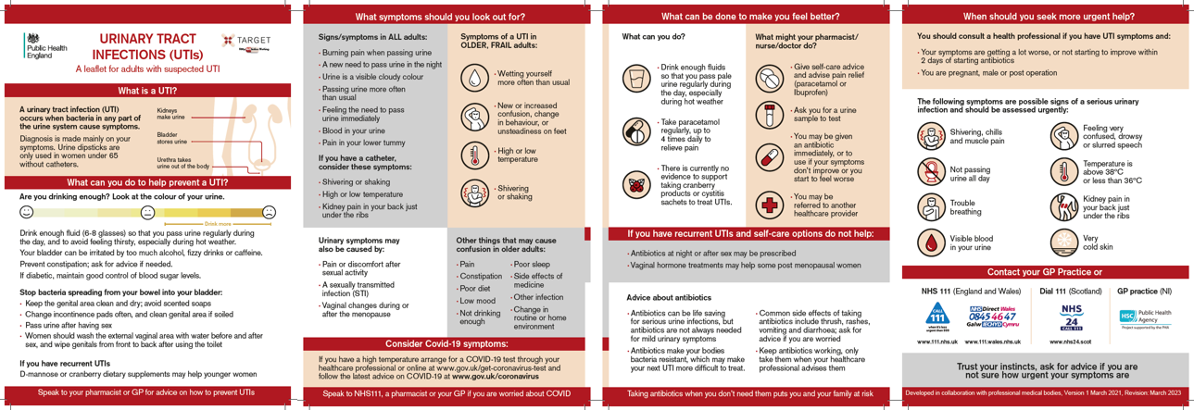
Use: This leaflet has been designed for use in the primary care setting, including general practice, community pharmacy and for use by carers and in care homes. It is suitable for consultations to facilitate dialogue between a patient or their carer and their healthcare professional on specific topics related to managing their UTI.

We are happy to receive feedback about how you have used this leaflet and any constructive comments on how it can be improved. Please contact the TARGET team via email at TARGETantibiotics@phe.gov.uk.

