Aim
To evaluate the diagnosis and management of urinary tract infections (UTI) in people over 65 years.
Audit criteria are based on Public Health England (PHE) and NICE guidance and tools

How to use this audit
Step 1: Familiarise yourself with the diagnostic and management of UTI guidance by reviewing:
PHE diagnostic flowchart figure 1: Flowchart for suspected UTI in catheterised adults or those over 65 years [PHE Quick reference tool for primary care]. The flow-chart discourages the use of urine dipsticks in this age group. This is because urine dipstick tests detect asymptomatic bacteriuria (ASB). ASB is more common in care homes than in the community and increases with age and long-term urinary catheter use. This flow chart is used to assess your practice’s or your individual compliance with the recommended algorithm. You can also visit the website for more information and the rationale behind all the recommendations: https://www.gov.uk/government/publications/urinary-tract-infection-diagnosis The diagnostic flow chart for women under 65 years may be more appropriate in some women over 65 years who are not in care homes
NICE/PHE UTI (lower): antimicrobial prescribing guideline Table 1: Familiarise yourself with the NICE/PHE Urinary tract infection (lower): antimicrobial prescribing guideline by reviewing Table 1 and 2: These tables cover 1) women aged 16 years and over 2) men aged 16 years and over. Use these tables to determine the proportion of your patients who have been prescribed the recommended antibiotics for UTI, including dose, frequency and duration. You can visit the NICE website for more information and the rationale behind the recommendations https://www.nice.org.uk/guidance/ng109
If there are symptoms of pyelonephritis or the person has a complicated UTI (associated with a structural or functional abnormality, or underlying disease, which increases the risk of a more serious outcome or treatment failure), see the recommendations on choice of antibiotic in the NICE antimicrobial prescribing guideline on acute pyelonephritis. You may wish to use your local primary care organisation’s antibiotic guidance for UTI as an alternative.
Please view the TARGET older adult UTI leaflet for self-care safety netting and other patient advice to share during the consultation or with carers.
COVID-19: Be aware that from March 2020 onwards, practice will have considerably increased numbers of remote consultation to limit patient and healthcare worker exposure to COVID-19. It is assumed that COVID-19 will have been excluded as a likely cause for high temperature.

Step 2: Search for 10-30 consultations relating to suspected UTI in older adults (use a minimum of 10 consultations, plus 1 consultation for every 1k patients if practice size is above 10k; maximum 30 consultations e.g. 15k list size = 15 consultations). The codes below are a sample of codes that can be used but consider adding codes that you or your colleagues are likely to use when you see older adult patients with UTIs. Searching for just a few codes that you usually use may identify all the consultations you require for the audit. Additionally, if you know coding is inconsistent, you may wish to search for patients over 65 who have been prescribed a UTI antibiotic i.e. Trimethoprim, Nitrofurantoin, Pivmecillinam, Fosfomycin, in the previous 3 months (Extend the time period if necessary). You may need to add ciprofloxacin, cefalexin and co-amoxiclav if these are used for UTI in your practice.
Exclude people from the audit who are identified because they are prescribed prophylactic antibiotics but who have had no episodes of suspected UTI during the search period.
K15 | Cystitis
K190 | Urinary tract Infection
1J4 | Suspected UTI

For an example of a search strategy used, please see appendix 1 for an EMIS screen shot.
Figure 1: Flowchart for suspected UTI in catheterised adults or those over 65 years
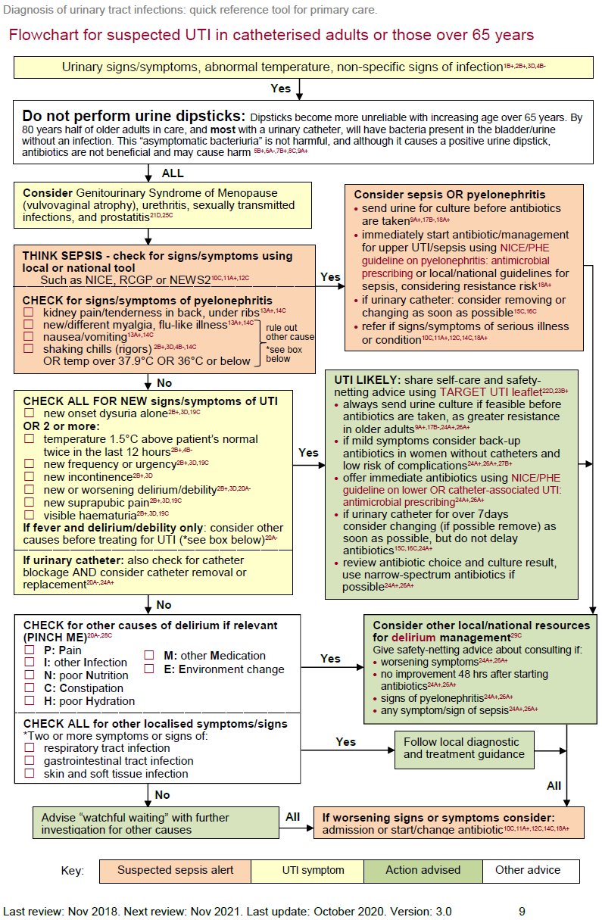
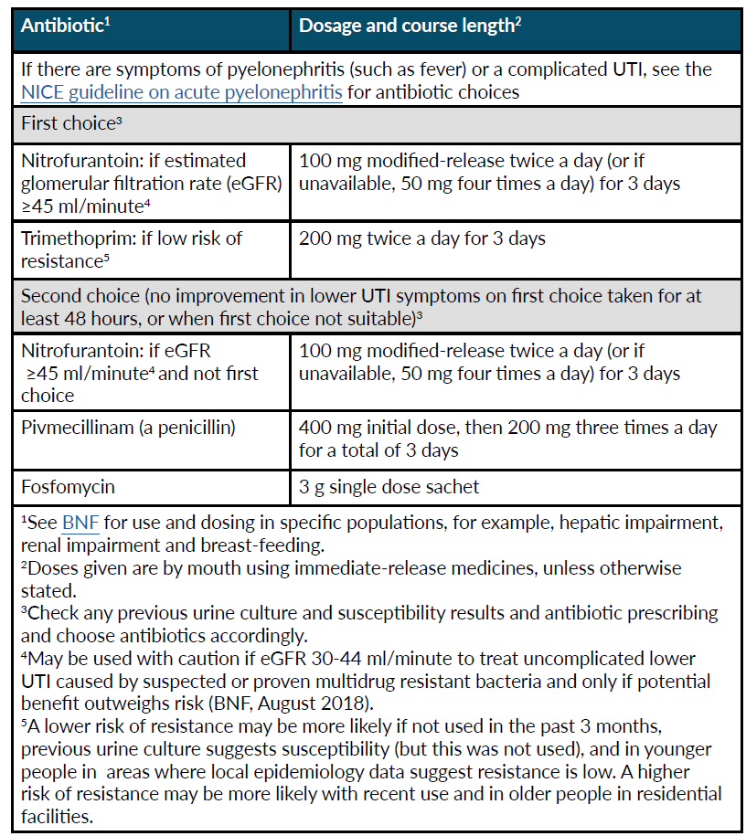
Table 1: Choice of antibiotic: non-pregnant women aged 16 years and over; NICE/PHE Guidance

Table 2: Choice of antibiotic: men aged 16 years and over; NICE/PHE Guidance
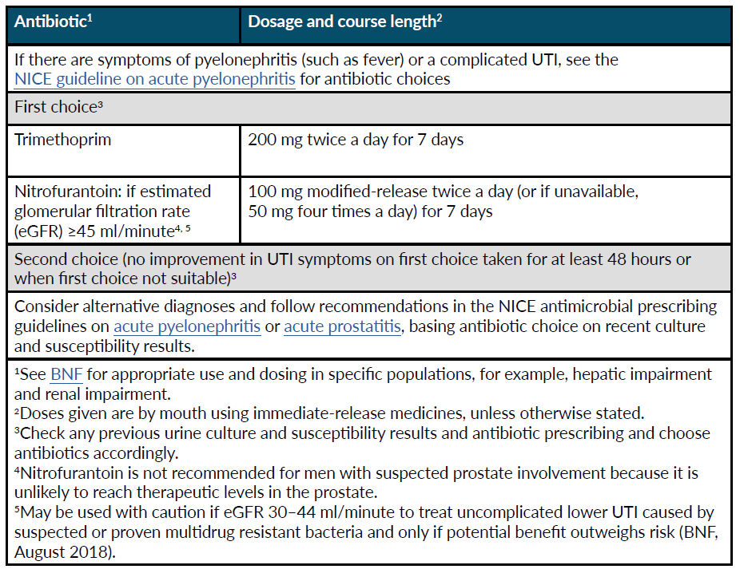

Step 3: Compete the data collection table below for each selected patient.
COVID-19: It is assumed that COVID-19 will have been excluded as a likely cause for high temperature.
Patients in audit consulting with suspected UTI, DO NOT HAVE URINARY CATHETER and are OVER 65 years
complete the table using the numbers 1 and 0 where yes=1, no=0
Compliance with PHE guidance for management of UTI in over 65s |  | 1 | 2 | 3 | 4 | 5 | 6 | 7 | 8 | 9 | 10 | 11 | 12 | 13 | 14 | 15 | 16 | 17 | 18 | 19 | 20 | 21 | 22 | 23 | 24 | 25 | 26 | 27 | 28 | 29 | 30 | Number of patients (N) | % of Total with UTI | Your target % for good practice
Patient ID
Diagnostic decision
A | Telephone/Surgery/Visit |  |  |  |  |  |  |  |  |  |  |  |  |  |  |  |  |  |  |  |  |  |  |  |  |  |  |  |  |  |  | T__S__V__ | T__S__V__
B | Female = 1 Male = 0 |  |  |  |  |  |  |  |  |  |  |  |  |  |  |  |  |  |  |  |  |  |  |  |  |  |  |  |  |  |  | F___M___
C | Clinician initials or role |  |  |  |  |  |  |  |  |  |  |  |  |  |  |  |  |  |  |  |  |  |  |  |  |  |  |  |  |  |  | __
D | Urethral/vaginal cause excluded e.g. notes mention absence of discharge, e.g. vulvovaginal atrophy, STI or urethritis
E | Pyelonephritis & sepsis assessed and recorded e.g.  • kidney pain  • new/different myalgia  • nausea/vomiting  • rigors  OR temp over 37.9°C or 36°C or below. |  |  |  |  |  |  |  |  |  |  |  |  |  |  |  |  |  |  |  |  |  |  |  |  |  |  |  |  |  |  |  |  | 100%
F | Features of pyelonephritis or sepsis present
Diagnostic criteria for UTI
G | New onset dysuria OR Two or more:  • temperature 1.5°C above patient’s normal.  • new frequency or urgency  • new incontinence  • new or worsening delirium/debility  • new suprapubic pain  • visible haematuria
H | If fever and delirium, do notes contain evidence of exclusion of other causes?
I | Was a dipstick used to inform your treatment decision?
J | Care/nursing home resident?  Y = 1, N = 0
K | Use of dipstick in care home meets guidelines (When J=1 and I=0)
Management decision / treatment
L | Immediate antibiotic given
M | Management decision meets Guidelines (When immediate antibiotic given L=1 above):  sepsis/pyelonephritis present (F=1), AND/OR Dysuria or two or more urinary symptoms (G =1)
Giving advice
N | Safety netting advice given about when to re-consult
O | Information shared on antibiotic use and resistance e.g. TARGET UTI leaflet for older adults
Compliance with giving advice
N=1 & O=1
If antibiotics were prescribed was the following correct? If not, add reason to notes below
P | Antibiotic choice correct:  1st line: Nitrofurantoin eGFR ≥45 ml/minute  or Trimethoprim (If low risk of resistance)  2nd line: Nitrofurantoin (if not first line), Pivmecillinam and Fosfomycin
Q | Dose/frequency correct:  Nitrofurantoin 100mg m/r BD (or if unavailable, 50mg QDS), Trimethoprim 200mg BD, Pivmecillinam 400mg stat then 200mg TDS, fosfomycin 3g single dose
R | Course length correct:  Women, uncomplicated lower UTI: 3 days  Add rationale in notes row if recurrent UTI or structural abnormality  Men: 7 days  Fosfomycin single dose
S | Was urine culture sent if antibiotics prescribed? Add rationale to notes row if not sent
T | Did culture result show organism resistant to antibiotic prescribed?
U | If culture result showed organism resistant to antibiotic prescribed, was the patient contacted to assess symptoms?
 | NOTES

Step 4: Summary of compliance and action planning

Overall compliance with NICE / PHE Guidance
- Proportion of consultations that are via telephone = ____% (Using row A)
- Proportion of patients where sepsis and pyelonephritis excluded = ____% (Using row E) Target 100%
- Proportion of patients where vaginal causes excluded = ____% (Using row D) Target 100%
- If fever and delirium(F=1), percentage with written evidence of exclusion of other causes (H=1) = ___% (Row H)
- Care/nursing home residents where treatment was not based on dipstick test. = ____% (Using row K)
- Management decisions meets guidelines if immediate antibiotics given (N=1) and or sepsis/pyelonephritis present (F=1) OR immediate antibiotic given (L=1) and dysuria or two or more urinary symptoms present (G =1) = _____%
- Overall compliance giving advice = ____% (If N and O =1)
- If antibiotics were used, total number given correct antibiotic, dose/frequency and course length (If rows ,Q and R =1) = ____%
- Proportion of patients where urine culture sent when antibiotics prescribed = ____% (Using row S)
- Percentage of cultures sent (S=1) which were resistant(T=1) = _____% (If row S=1) (If over 20% consider in those resistant whether antibiotic choice is correct)
- Proportion of patients contacted(U=1) if results shows resistance (T=1) to antibiotic prescribed = ____%
What can you do to improve guidance compliance?
The 3 criteria we had the best compliance with are: | The 3 criteria which are priority areas for discussion:
1. | 1.
2. | 2.
3. | 3.
Reflection: How will I improve our low compliance? | Reflection: How will I maintain our good compliance?
Tips to share with other practices and clinicians: ______________________________________________
Things that might help are:
- Agree a diagnostic and treatment target and repeat the audit after 1 - 3 months
Things that could help you:
- Monitor use of Urine dipsticks in your practice
- Promote use of PHE or local antimicrobial/management of infection guidelines in practice
- Encourage use of TARGET Treating Your Infection – Urinary Tract infection (TYI-UTI) leaflet for older adults
- Share TARGET TYI-UTI leaflet on clinical system
- Promote and conduct TARGET webinars and eModules
Re-audit in ____ months, identify a date when you will repeat the audit ( ___ / ___ / ___ )
Appendix 1
