**TARGET Treating Your Infection**

***Respiratory Tract Infection (RTI) Leaflet***

**User Guide**

**Summary**

Patient leaflets outlining the natural history of respiratory tract infections and information about when to re-consult can result in reduced antibiotic prescribing. The TARGET *Treating Your Infection - Respiratory Tract Infection* (TYI-RTI) *Leaflet* was developed as a tool to share with patients in the consultation to educate them about using antibiotics responsibly.

**What are the aims of the Treating Your Infection (RTI) leaflet?**

The leaflet aims to give information, in line with NICE guidance on:

* The natural course of self-limiting infections
* How people can self-care
* Explicit advice on when to seek medical help
* Appropriate antibiotic use and the side effects of antibiotic

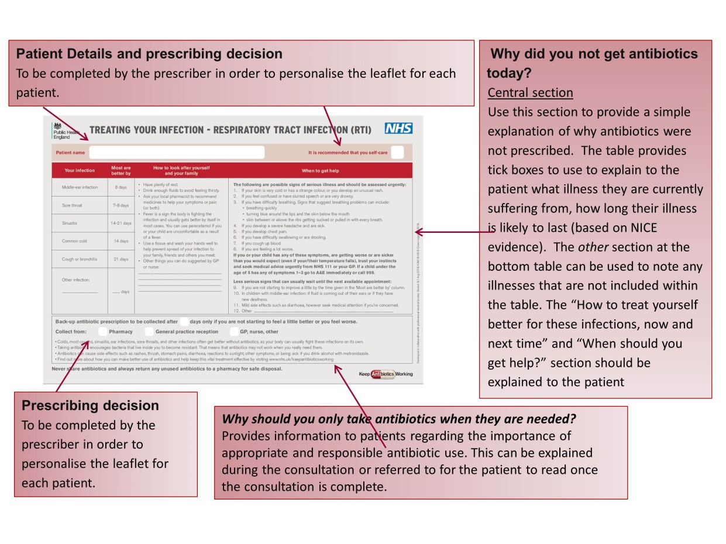

**Overview of the leaflet**

To use this leaflet properly, it is important that it is used as a tool to interact with patients, rather than as a ‘parting gift’. In order to do this effectively you should be familiar with its content.

**Why create the Treating Your Infection (RTI) leaflet?**

Prescribers often feel caught between pressure of not to prescribe antibiotics and expectations from patients to prescribe. However, there is evidence that prescribers often overestimate patients’ expectations for antibiotics, and that many patients, when they are fully informed about the modest benefits and potential harms from treatment, would rather not receive antibiotics. 70-80% of all antibiotics are prescribed in the community, therefore sharing leaflets with patients presenting with RTI’s significantly reduces inappropriate use of antibiotics.

**NICE endorsement**

The TARGET TYI-RTI leaflet specifically relates to the following NICE guidelines:

* [NG15 Antimicrobial stewardship: systems and processes for effective antimicrobial medicine use](https://www.nice.org.uk/guidance/ng15): 1.1.31, 1.1.33, 1.1.34
* [NG63 Antimicrobial stewardship: changing risk-related behaviours in the general population:](https://www.nice.org.uk/guidance/ng63) 1.3.2,1.5.5 and 1.5.6

We are happy to receive feedback about how you have used this leaflet and any constructive comments on how it can be improved. Please contact us at [TARGETantibiotics@phe.gov.uk](mailto:TARGETantibiotics@phe.gov.uk).

**The leaflet has been endorsed by the following bodies**

