Focus Group Results
This is an example template to report your Focus Group results. It can also be used to support analysis; by tallying results into a printed version and adding quotes as you re-listen to the focus group recording. Areas to edit are highlighted by [square brackets], instructions are in italics and pink font - remember to remove all these pink instructions.
[ADD Practice Name, Date: Mode and Time of Focus Group]

Representation
Focus Group
Male
Female
Age Range

Benefits and Barrier themes from the session
Many of the common benefits and barriers were shared within the focus group discussions, listed underneath these continuity word cloud examples are the themes shared by this group. A fuller analysis and example quotes are shared from page 3. [update the page number as this will change when you add to the document]
Benefits of Continuity | Challenges/Barriers to Continuity
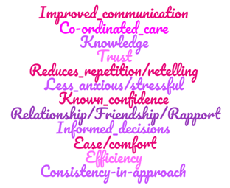 | 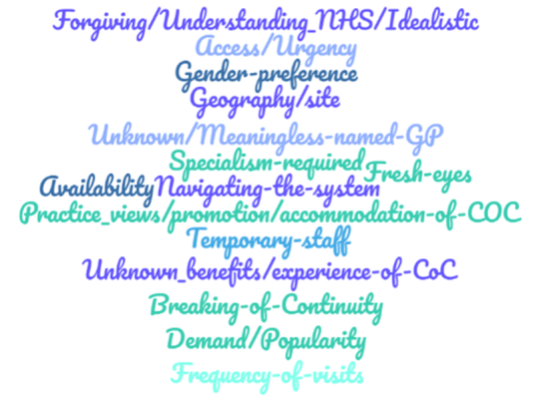
- [Theme]  - [Theme]  - [Theme]  - [Theme]  - [Theme]  - [Theme] | - [Theme]  - [Theme]  - [Theme]  - [Theme]  - [Theme]  - [Theme]

Improvement Areas
Within the discussion there were some issues that were highlighted as possible areas for improvement from a continuity and practice perspective.
[ADD an overarching area for improvement in column 1 and quote in column 2 OR simply replace table with a subtitle and bullet point list e.g. appointment booking/navigation, knowing GPs]
Continuity Improvements
Improvement area | Quote example

Other Practice Improvements
Improvement area | Quote example

Thematic and content analysis
[You can use the 3 tables below in printed form as a tally/note sheet when listening to a video or audio recording; tally the number of times a theme is mentioned and add the time of the recording to return to if you hear a good example quote. This information and the quote in full (removing any personal identifiable information) can be typed into the electronic document. The number of times the theme was mentioned in column 2 and an example quote in column 3. Note the themes listed here are taken from many focus groups; delete rows where the theme was not mentioned in yours]
1. Benefits to Continuity :Themes, number of mentions and example quote
Theme | No. | Example Quote
Consistency in approach
Co-ordinated Care
Ease/comfort
Efficiency
Improved communication
Informed Decisions
Knowledge
Known confidence
Less Anxious/stressful
Reduces Repetition/retelling
Relationship/Friendship/Rapport
Trust

2. Challenges/Barriers to Continuity: Themes, number of mentions and example quote
Theme | No. | Example Quote
Availability

Access/Urgency
Breaking of Continuity
e.g. GP leaving/on LT leave
Demand/Popularity
Forgiving/ Understanding NHS/Idealistic
Frequency of visits
Fresh eyes
Gender preference
Geography/site
How practice views, promotes or accommodates COC
Navigating the system
Specialism required
Temporary Staff
Unknown benefits/experience of
Unknown/Meaningless Named GP

3. Important when not seeing the same GP: Themes, number of mentions and example quote
Theme | No. | Example Quote
Attitude
Actively listened to
Choice
Confidence in ability
Continuity with a few GPs/preference priority list
Face-to-face contact
Feeling at ease/comfortable/quick rapport
Informed ahead of consultation
Knowledgeable of own problem/medication and communicating it
Team
Telephone call with own GP
Up to Date Information/Pertinent info

