How to Map a Process
The following is a simple guide on how to use conventional process maps with a focus on continuity. Common processes to map in order to identify the challenges and opportunities for continuity are outlined in the Continuity of Care Toolkit.

About Process Mapping

What is a process?
A set of connected activities, material and/or information flow that transform a set of inputs into a defined output.

What is a process map?
A visual representation of a process (any process, large or small), created by the people who operate and interact with the process.

Purpose of process maps
- Identify opportunities, helping you to identify areas of improvement
- Identify steps that don’t add value (wastes – inefficiencies/duplication)
- Identify problems affecting flow (bottlenecks: process steps that restrict flow, and constraints: cause of what is restricting the flow)
- Understand what actually happens – the current state (not just what is supposed to happen) with a no blame approach
- Provide measureable baseline – where we are now
- Can co-create, visualise and share a process redesign (future state map)
- Encourage involvement and ownership (this is greater the more stakeholders you involve). It can also enable stakeholders to see the full process that they may only be a small part of and understand from other perspectives – it can be empowering and cathartic

Different process mapping approaches
There are several different ways processes can be mapped, this guide focusses on conventional process mapping. Other ways include: Process Template; Spaghetti diagram; Value Stream Mapping; Mapping last 10 Patients; Tracer Study; Experienced Based Design.

How to Map
Before you start mapping, you need to be clear on what you want to map and why. In terms of continuity the possible processes to map and their rationale are included in the Continuity of Care Toolkit. Process mapping is a 2 stage approach, mapping the now and the future – don’t stop once you’ve mapped the process.

Creating a current state map
Maps are best created with a range of stakeholders and with a large space using large sheets of paper and sticky notes. However, they can be done virtually, created electronically, with a small group or several 1:1s and built up.

Use the map symbols/your own key to:
- Define the scope of process to be mapped (start and end point) –the first and last process step (the first and last step written on yellow sticky notes). This can be decided in advance.
- Start with high level map (Macro Map) of 5 to 10 process steps (major steps in the process), to provide the frame for a more detailed map.
- Build a more detailed map (Micro map), working in between the frame built by the Macro Map e.g. who does what and when. The detail will include more process steps, decision points (where the process can go in different directions), problems or concerns, where information is provided/needed to inform the process.

The right level of detail will become apparent “as you go”, the best map is the simplest map that makes things clear and provides insight. Mapping is an iterative process.

Map symbols
This is a guide, as long as you include a key on your map you can use different colours and pieces of paper stuck with sticky tape (they just need to be defined and moveable). There are 3 main symbols (the top 3 in the table identified by an asterisk (*)) the others are helpful additions and dependant on the complexity of the process being mapped.
Symbol |  | Description | When to use
 | Yellow sticky note | Process step* | Shows a task or activity performed in the process (performed by one person, in one place, at one time).
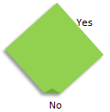 | Green sticky note | Decision point or question* | Shows a decision point in the process or when a question is asked​.
 | Pink sticky note | Problem or concern* | Shows when a problem or issue is found (usually placed adjacent to the applicable task or activity)​.
 | Orange sticky note | Information/input | Shows when information or an input is needed or informs a decision or step.
Start | End | Start and end point labels | To show the start and end point of the process.
 |  | Process or information flow direction | Shows the direction that the process flows, rework loops etc. take (helps people read the map)​.
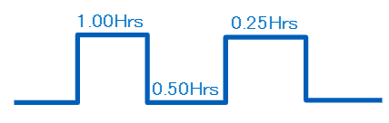 |  | Timeline (optional) | Castellated line used to show timings for each process step.​
 |  | Value indication (optional) | Stickers placed on the completed process steps to show value added, and non-value added​. The yellow dot is a necessary waste.

Equipment for process mapping

- Mapping paper (parcel paper/lining wallpaper works well)
- Good quality sticky notes
- Marker pens
- Reusable adhesive e.g. BluTack
- Scissors
- Sticky tape
- Flip charts (for ideas and niggles)

Facilitating a session
Whilst it is great to have an experienced facilitator for a mapping session, it is not essential. However, there are some key roles that are useful to organise for the session, those taking on these roles will not being able to fully participate (it can be beneficial that these roles are undertaken by those not involved in the process – they can ask the ‘silly’ questions and be objective).
- Facilitator: Someone to direct the session, allowing time to add detail when needed and move stakeholders onto the next step when it’s not.
- Scribe: Someone to write the steps, decisions and problems.

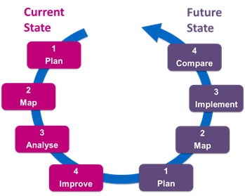
2-Stage approach
Process mapping generally involves two stages; current state mapping and future state mapping. It is a cyclical process of continuous improvement, as ‘The Future State’ will be the current state after a certain period of time.

Mapping the CURRENT state |  | Mapping the FUTURE state
Plan | - Agree purpose and scope of the mapping (start and end points)  - Gather stakeholders (who should be involved)  - Gather any preliminary data/information (numbers through the process/patient feedback or issues recorded) | Plan | Prioritise the required changes (from current state map problems/improvements)
Map | Make the map (date and title it too)  - Start high level  - Add detail including problems/concerns  - Share (photo or electronically recorded) and check the map is correct  - Secure the map e.g. sticky tape the sticky notes on | Map | Create future state map using the same process as the current state (it usually takes less time)
Analyse  (analysis tables in appendix 1 & 2) | Analyse the map, look at the flow  - What are the challenges and opportunities for continuity?  - How much is value added and how much is waste? | Implement | Implement (e.g. via PDSA test cycle) and confirm the results
Improve | Look for improvement  - Can the flow be changed?  - Where can continuity be encouraged?  - What wastes can be reduced/eliminated? | Compare | Now you have a new current state, how does it compare with the future state plan? Is this the end for now or do further changes need to happen?

Appendix 1: Analysing Process Maps
Questions | Answers
How many steps are involved in the process?
Are all the steps necessary? Which are not?
What steps don’t add value?
Where are the bottlenecks or queues?
Where are the problems? (pink sticky notes)
Do we have all the data to answer these questions? What data is needed?
What waste has been identified? Is there any duplication?
(8 wastes: TIMWOOD)
What waste can be eliminated?
Where are the opportunities for improving Continuity?
How can the flow be changed? To do the right things in the process in the right order by the right person

Appendix 2: Identifying Wastes (8 Wastes: TIMWOODS)
Process/Area of work:
TYPE OF WASTE | Example
1. Transportation | When customer/patient information or items get handled by too many staff without adding value
2. Inventory | Excessive stock in store rooms not being used; customers waiting in a queue
3. Motion | Staff walking to other end of department or building to pick up equipment or paperwork
4. Waiting | Service users waiting for appointments, visits, procedures
5. Overproduction | Duplicating recording of information, multiple forms or leaflets same information
6. Over-Processing | Asking service users for details several times, emails – reply to all, chasing up information or appointments
7. Defects | Repeat tests, readmission, drug reactions
8. Skills | Not listening to issues raised by the staff; or not involving staff in improvement work

Appendix 3: Examples of Maps

Current State Appointment booking process by call or face-to-face
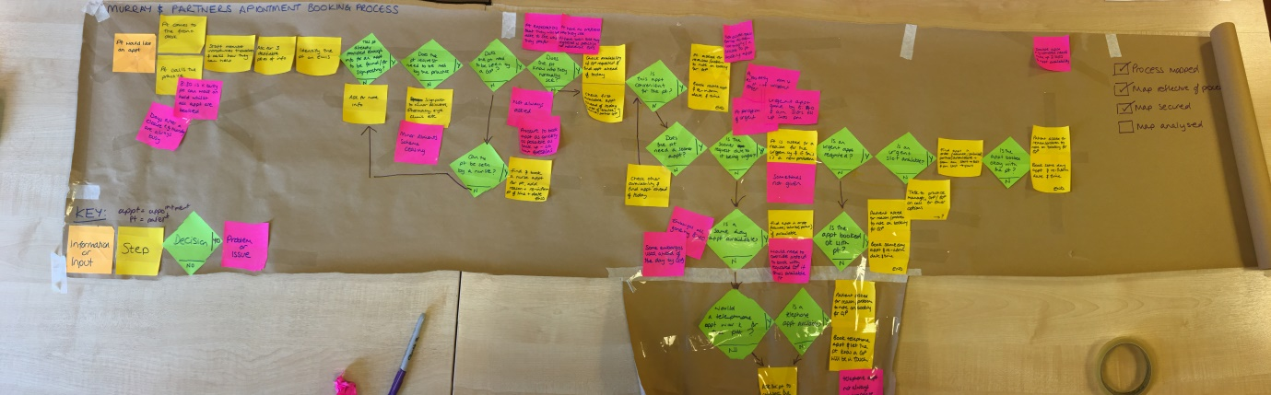
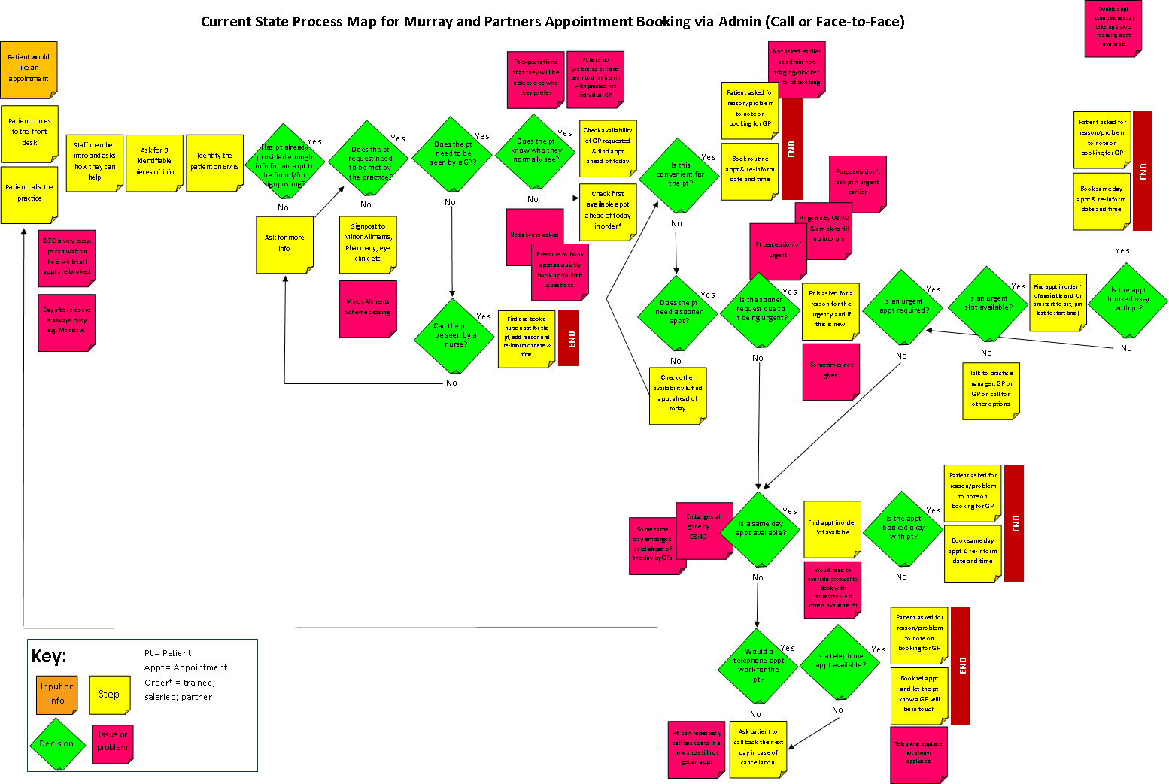
After a few sessions with the administration team and a very messy process map, the map was redrawn so it could be displayed during a practice training session to be shared, checked and analysed before working on a future state map. It was also typed up so an electronic record could be kept and viewed on screen as the paper version was too large to remain displayed.
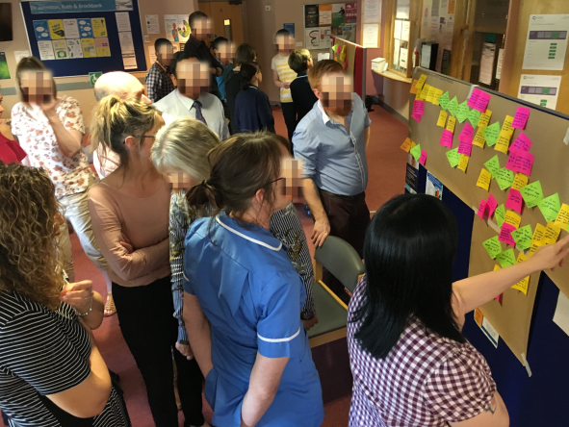

Future State Appointment booking process by call or face-to-face
The future state map built by fewer stakeholders followed the analysis, which identified duplication and an improved order for asking questions. This was displayed so all could influence the future process and visualise what it may look like, ahead of testing as part of a PDSA cycle.
