PDSA Template
Overall Aim
PDSA Cycle Aims |  |  | 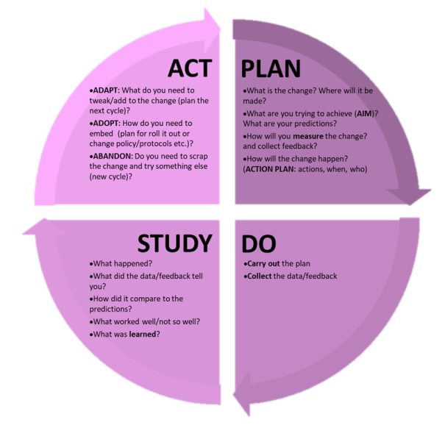
1
2
3
4

PDSA Cycle 1 AIM/QUESTION
Describe your first (or next) test of change
PLAN
List the tasks needed to set up this test of change |  |  |  |  |  | Person responsible | When to be done
DO - RUN THE TEST
From |  |  |  | To
STUDY
Describe what actually happened when you ran the test
Describe the measured results and how they compared to the predictions and what you learned from the cycle

ACT (Adapt, Adopt or Abandon)
Describe modifications for the next cycle based on what you learned

