Continuity of Care Guide

For General Practice

Patient Participation Groups
Contents
Introduction to Continuity of Care Tool 2
Using the Slide Deck 2
Slide 1 – Title slide 2
Slide 2 – What is continuity of care? 2
Slide 3 – Why is continuity important? 2
Slide 4 – Types of continuity 3
Slide 5 – What happens? 3
Slide 6 – Patient Barriers 3
Slide 7 – Research and evidence 3
Slide 8 – Patient preferences 5
Slide 9 – Patient perspectives 5
Slide 7 – Practice influences 5
Slide 11 – Annual GP patient survey 6
Slide 12 – Approaches to continuity. 8
Slide 13 – System Challenges 9
Slide 14 – Supporting the practice 9
Slide 15 – Suggested reading 9

Introduction to Continuity of Care Tool
This guide, and the accompanying slide deck, are to support you in delivering a session on continuity of care to your Patient Participation Group (PPG). The aim of the session is:
- Information giving – share why continuity of care is important.
- Information receiving – capture the views of your members. You may like to focus on 3 key areas:
  - Why and when is continuity important and for which patients?
  - What are the views of your PPG members on continuity of care?
  - How can your PPG support the practice to improve continuity of care?

Using the Slide Deck
- Please select the slides from the deck that help you to deliver your session.
- Some slides include a ‘discussion’ question which can be deleted if not needed.
- You may wish to hide some slides, so they are not visible when you present them. If you would like to hide a slide, then select it and right click on mouse which will give a list of options, select ‘hide’. If you wish to unhide it is the same process, click ‘hide’ again.

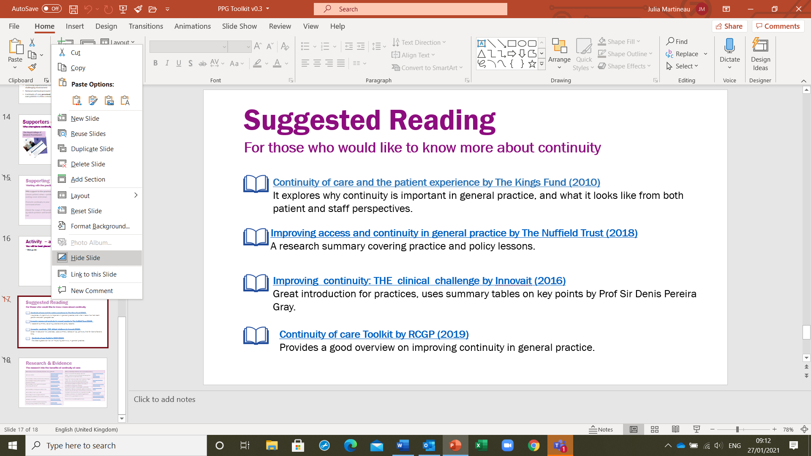

Slide 1 – Title slide
Please adapt for your own presentation.

Slide 2 – What is continuity of care?
This slide is scene setting. It can be useful to start members by asking what they think is continuity of care. The slides include some views to get you started.

Slide 3 – Why is continuity important?
The summary shared on this slide is taken from the Nuffield Report (the full report can be found at Slide 15). This report covers the key research into continuity of care up to 2018.
There is a wealth of research into continuity covering several decades. Research into continuity continues and includes 2 papers in 2020 which found:
- continuity reduced adverse incidents.
- patient satisfaction with the practice increased where there was continuity.

Slide 4 – Types of continuity
There are different types of continuity all of which co-exist. A practice may be providing relational continuity, (i.e. patient sees one GP) which is supported by informational continuity (an up-to-date patient record). Maintaining the patient record means anyone seeing the patient has a full picture of the patient’s history. Sometimes a patient may need to see another GP for a particular treatment or condition, which is referred to as episodic continuity. This may be because:
- a particular GP has a particular interest in a condition.
- the patient began treatment with a particular GP and prefers to continue with them during this episode.
- a male patient wishes to see a male GP for a particular condition.

There is also managerial continuity when there are several practice staff caring for a patient. This could include GPs, nurse practitioners, phlebotomists, navigators etc.

Slide 5 – What happens?
This graphic is reproduced with the permission of Professor Chris Salisbury who is based at Bristol University and was a GP in one of the Bristol practices.
The diagram is read from left to right. It identifies what happens when there is continuity. We see that where the patient sees the same GP, they build trust and in turn a relationship is established between GP and patient. The research into this relationship has found it brings many benefits to both GP and patient with both reporting increased satisfaction with the care provision.

Slide 6 – Patient Barriers
In this slide, the focus is on the barriers to continuity. The examples given have been collected from patients involved in previous continuity of care sessions. For example, one patient asked, ‘What happens if you have a GP you don’t wish to see?’. If this were to happen, the patient can choose to see another GP, assuming the GP has capacity. The responses to the questions already raised are set out in the table in the slide but what questions do your members have? If you are unable to answer them during the session pass them back to the continuity of care lead within the practice.

Slide 7 – Research and evidence
There is a wealth of research into continuity of care and below are the links to research on the benefits to patients and a further list showing the benefit to doctors.

When they receive continuity of doctor care, patients:
Are more satisfied​ | Baker and Streatfield (1995)​  Baker et al (2003)​  Adler et al (2010)
Are more likely to follow medical advice (adherence)​ | Warren et al (2015)​  Chen et al (2013)​
Are more likely to take up offers of personal preventive medicine​ | O’Malley et al (1997)​  Christiakis et al (2003)​
Are more likely to have a good doctor patient relationship with their GP​ | Mainous et al (2001)​  Ridd et al (2011) ​
Are more likely to receive good quality of care​ | O’Connor et al (1998)​  Romano and Segal (2015)​
Are less likely to need to go to A&E​ | Brousseau et al (2004)​  Van den Berg et al (2016)
Are less likely to need a hospital admission, particularly for ambulatory care sensitive conditions​ | Barker et al (2017)​  Bankart et al (2011)​
Are likely to live longer​ | Maarsingh et al (2016)​  Pereira Gray et al (2018)​
Have more cost-effective healthcare (including meaning funding available for other things).​ | Starfield (1994)​  Weiss and Blustein (1996)​

When continuity of doctor care is provided, doctors:
Have an ‘accumulated knowledge’ about the patient. Doctors use such accumulated knowledge both for diagnosis and to tailor their advice. ​ | Hjortdahl & Borchgrevink (1991)  Hjortdahl (1992)  Ridd et al (2011)​
Report that continuity enables them to provide ‘higher-quality’ care. ​ GPs are then rewarded with more professional satisfaction through doing a better job. ​ | Ridd, Shaw, & Salisbury (2006)​
Have improved problem recognition and quality of management for long-term conditions​. | Saultz and Lochner (2005)​  Baird et al (2018​)
Have reduced conflicts of responsibility, particularly reducing the ‘collusion of anonymity’ where a succession of clinicians only deals with what is immediately most pressing​ | Freeman and Hughes (2010)​
Contribute to the reduced the use of specialist care, A&E, emergency admissions and outpatient appointments​ | Hansen et al (2013)​  Katz et al (2015​)
Reduce costs ​e.g. prescriptions and tests​ | Weiss and Blustein (1996)​  Saultz and Lochner (2005)​
Reduce cases of avoidable significant harm | Avery et al (2020)

Slide 8 – Patient preferences
This is where PPG members can help the practice by exploring what are the factors they believe influence a patient’s preference for continuity. There are some thoughts provided on the slide but what is needed is the local view. PPG members can help to identify characteristics of patients they would assume would prefer continuity. Perhaps patients who long-term conditions would value continuity more than someone who rarely consults the doctor and is in full time work.

Slide 9 – Patient perspectives
This explores when, why and where continuity is important, and PPG members are asked to discuss to capture local perspectives. The concept of continuity will be well understood by Baby Boomers, who in their formative years were treated by the ‘family doctor’ who lived locally and provided care every day of the week. Younger patients may not have considered or value continuity, preferring instead to have quick access.

Slide 7 – Practice influences
Patients – Studies have shown that areas of high deprivation and poor education are likely to reflect low levels of continuity. Continuity is more difficult for working age patients who are looking for an appointment that fits with their working hours. Consider the demographics and geography of your practice and how it might influence continuity for patients?
Appointment Types – There are 24 practices participating in the One Care project and all focus on continuity of care for routine appointments only. This is because providing continuity of care for urgent appointments is very challenging with many GPs working part time and rapid access takes precedence. A practice may use an ‘urgent’ list with a GP as Duty Doctor so continuity is not possible for those who do not have this GP as their usual GP.

Conditions - There are conditions or treatments that particularly benefit from continuity and where both GP and patient prefer to have continuity. For example, a patient having an acute episode may prefer continuity for the duration of that episode. The episode may only last a few weeks or months, but the patients see the same GP for the duration. Other conditions where continuity is particularly helpful includes cancer patients, mental health conditions, drug, or alcohol dependency or those with long term conditions.
Practice Staff - A key factor in providing continuity is the support and enthusiasm of the Practice Team. Continuity of care is a whole practice approach so there needs to be a practice culture of continuity. It begins with the Reception Team who steer and support patients to see their usual GP. The patient record may be updated to reflect the patient’s usual GP to support informational continuity. One of the keys to success found by the One Care project was enthusiastic GPs at the practice. The project found GPs welcome having a patient list, being responsible for their patients. It is one of the reasons many are attracted to general practice and that is true of younger GPs too.
High Profile Support - Success is also linked to having high-profile support. Rapid access is currently high on the NHS agenda to ensure patients are seen promptly. There is a growing awareness that access and continuity should co-exist and the supporters of that cite the evidence of the benefits of continuity. Supporters include:
- The Royal College of General Practitioners, which is the professional membership body for GPs. It believes continuity of care is important and they have assigned a GP to lead on Continuity of Care and are hosting the Continuity of Care Toolkit of which this is part.
- Patient Groups also recognise the importance of continuity. For example, if you read the BNSSG Healthwatch publication in response to the NHS Long Term Plan you will see that, based on patient feedback, the report recognises the value patients place on continuity.
- The Health Foundation is an independent charity committed to bring about better health and health care for people in the UK. It provided funding for One Care, Bristol, to work with BNSSG practices to explore ways of improving continuity of care. The project covered c. 400,000 patients in the BNSSG area. The Health Foundation also funded 4 other projects, each exploring other aspects of continuity of care. They were St Leonard’s, Exeter, Morecambe Bay, Pier Health in North Somerset and the Valentine Partnership, London. The results of all 5 projects will be available on the Health Foundation website.

Slide 11 – Annual GP patient survey
This slide focuses on the results of the annual GP Patient Survey for your practice. The survey is a source of data to help you understand how the practice is doing on a range of issues, including continuity.
There are several questions but for a measure of continuity look at how respondents answered the question ‘How often do you see or speak to your preferred GP when you would like to?” This is an indicator of the level of continuity of care at the practice although it is useful to check the number of respondents as the results are based only on those who responded.
Step by Step to building your practice slide:
- Click on the link GP Patient Survey (gp-patient.co.uk
- In the search box, type the name of your practice and press ‘go’
- If your practice has a common name you may need to select from a list the correct one
- Once into the Practice data there are 3 tabs –
  - Practice overview
  - Patient experience
  - Compare practice
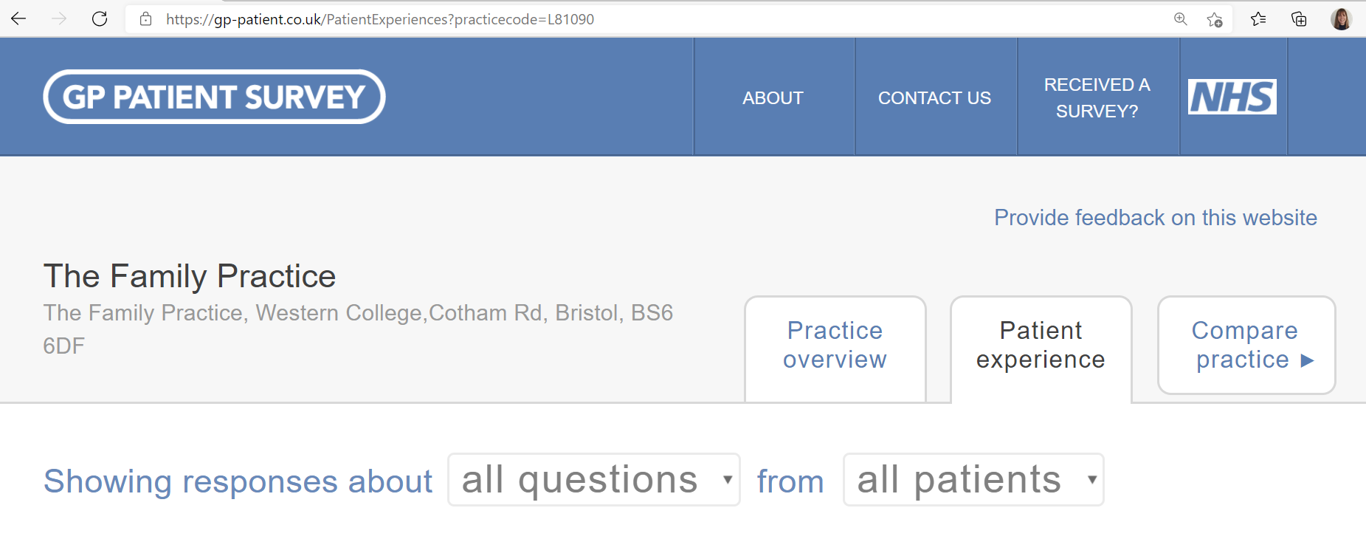
- Select the patient experience tab.
- Scroll down to find the results to the question X5 usually get to see or speak to their preferred GP when they would like to and click on the button ‘show breakdown’.
- This will display a screen like this:

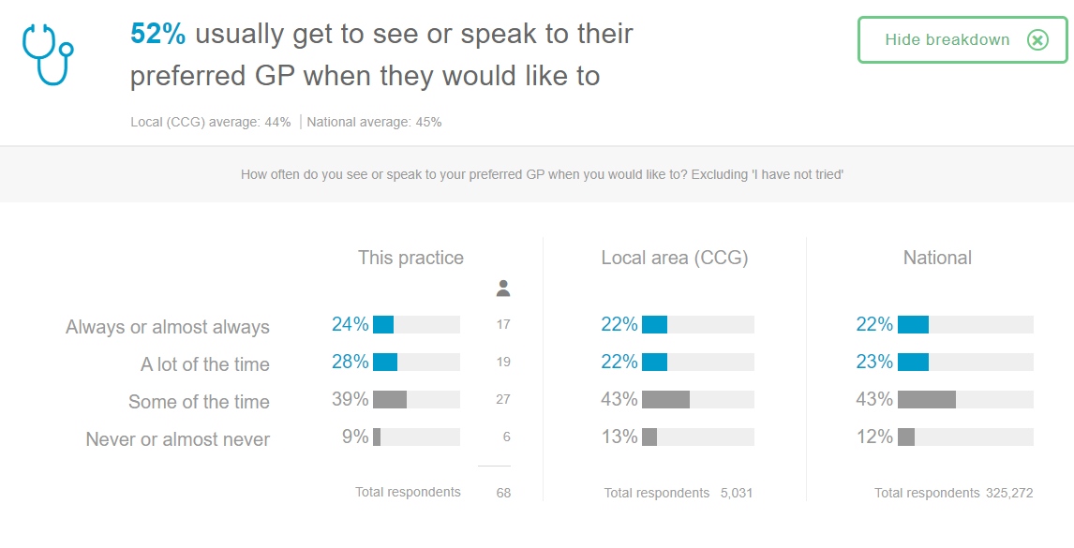
- Take a screenshot of the image, crop it and add it to the PowerPoint.
- Note the data includes the practice score, compared to the local area and nationally.
- You may also like to do a comparison of the results for your practice with another and this can be done by selecting the ‘compare practice’ tab (see step 4 above).

The graph below shows some of the Bristol practices that participated in the One Care continuity of health project. You will see there is a wide range of results from 27% to 68% so looking at the local and national average is useful as a benchmark.
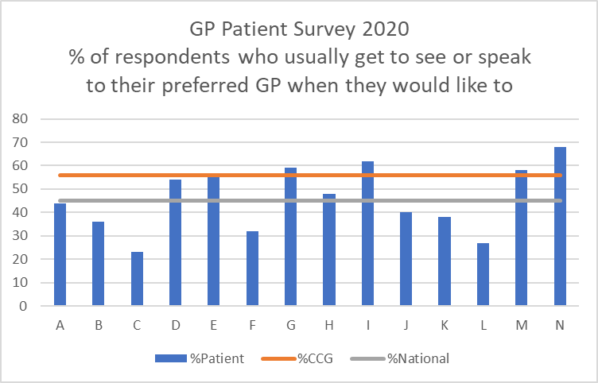

There was an earlier reference in the slides of research in 2020 and it included Tammes et al (Dec 2020) who used the GP survey data and concluded that patients who reported having good experiences of appointment making at the practice was linked to being able to see their preferred GP.

Slide 12 – Approaches to continuity.
This slide is looking at what your practice can do to begin their journey to improve continuity of care. There are essentially 2 main questions to answer.
- Will the practice be looking to provide all patients with continuity, or will they focus on a cohort?
- Will the practice be looking at continuity provided by an individual GP or by a microteam (or more than one clinician)?

These questions will require careful consideration by the practice. Smaller practices are usually better able to bring about change more quickly whereas the larger and the multi-site practices have a greater challenge. If the practice has a high number of GPs who work part-time this may steer the practice towards a GP and a GP buddy. The GP who is the buddy caring for the patient when the usual GP is unavailable. Another factor practices will need to consider is patient turnover; the greater the turnover the less continuity that is possible.
A key part of improving continuity is for the practice to set realistic goals and work within the constraints of a shortage of GPs, of greater workloads in general practice, and GPs opting to work part-time.
The practice ambition may be to improve continuity for all patients but to achieve it, the work will need breaking into manageable chunks. Many practices taking part in the One Care project, focused on cohorts of patients, for example those who frequently attended the practice, frail patients, end of life patients, mental health patients and patients over 80 years old. Getting the process right for a small group and then expanding the process to include more patients.
A Toolkit is available to the practice which shares the learning from One Care practices and includes several tools to help the practice along with a tool to measure continuity.

Slide 13 – System Challenges
In this slide we consider the challenges. Your PPC discussion on this is useful for the practice. We have learnt that support from the PPG is important in overcoming the challenges.
There are several challenges including difficulty in recruiting clinicians, particularly in attracting doctors into primary care, there are the wider reconfigurations with practices needing to move forward as one, and there are disparities in service, deprivation and so on all of which mean managing patient expectations is vital. The PPG is well placed to support the positioning and marketing of continuity because it can contribute knowledge of patient’s perceived barriers, which patients value continuity, their experiences, and views.

Slide 14 – Supporting the practice
This slide is to support discussions on how the PPG and the Practice can support each other on the journey to improving continuity of care. Again, this is an area where local ideas need to be captured and shared with the project lead.

Slide 15 – Suggested reading
The links below are for those who would like to know more about continuity of care in general practice.
Continuity of care and the patient experience by The Kings Fund (2010)
The Kings Fund explore why continuity is important in general practice, and what it looks like from both patient and staff perspectives. The study was some time ago but the findings remain relevant.
Improving access and continuity in general practice by The Nuffield Trust (2018)
This is a useful research summary which includes all the practice and policy lessons up to 2018.
Improving continuity: The clinical challenge by Innovait (2016)
The author, Professor Sir Denis Pereira Gray, introduces continuity within general practice. A retired GP, with a lifelong passion for continuity of care, Professor Gray is considered one of the authorities on continuity of care.

