Reception Team Guide
Contents
Introduction 1
Key benefits of Continuity of Care for Reception Team 2
Introduction 2
Improving Continuity of Care 2
Challenges 2
Changing Usual GP 3
Conversion to a Home Visit 3
Prescriptions 3
Frequent Attenders 3
Hints & Tips 3
Script 3
Phrasing - 3
Clarity 3
Reminders 4
Review 4
Information Continuity 4
Use your practice welcome message to remind patients 5
Suggested EMIS Prompts 5
Keep learning 5
Current and Future Navigation/Information 6

Introduction
This document has been produced with the help of Reception Staff from practices that participated in the One Care Continuity of Care project. It is based on their experiences. We hope it will be useful to you and we look forward to adding your ideas and suggestions.
Dr Mark Richenback, RGGP Clinical Lead for Continuity of Care sees continuity in terms of frontstage and backstage. Both need the commitment of the whole practice team and that needs to be underpinned by a good IT system.
For Mark, Frontstage continuity is face to face care with the same person. It is the patient and practice team getting to know one another.
Whereas Backstage continuity, is seamless access to the medical records and results. It is a collective understanding and shared knowledge of the healthcare team looking after that person.
With Mark’s view in mind, you can see continuity of care is a whole practice initiative.

Key benefits of Continuity of Care for Reception Team

Introduction
There is plenty of research demonstrating Continuity of Care benefits both patients and GPs. The Practice’s Reception Team is vital in implementing and maintaining continuity of care.
The practice may decide to focus on providing continuity of care for cohorts of patients or they may look at continuity for all patients. The decision is dependent on several factors – the size of the practice, the views of patients and staff, the sessions the GPs work each week and so on.

Improving Continuity of Care
Where a patient would benefit from continuity of care, Receptions Teams we have worked with agree that maintaining the ‘usual GP’ field supports the Reception Team in making appointments and directing tests results and other communication.
You can help support continuity of care for your patients by:
• Asking patients who their Usual GP is when they call into the surgery to reinforce they have a usual GP
• If patients do not know their Usual GP, remind them
• Offer patients the next available appointment with their Usual GP before looking at other available slots
• For non-urgent queries, explain to patients the benefit of waiting to see their Usual GP.
• If patients do not wish to wait to see their Usual GP, explain why continuity of care is important. Start by saying ‘seeing the same person each time you visit can have real benefits for your health’ however bear in mind patient choice
• Give the patient a copy of the continuity of care patient leaflet
• Check the ‘Usual GP’ field on EMIS is up to date and accurate

Challenges
Occasionally patients can be challenging, sometimes aggressive, because they do not understand why they need to provide details to reception staff. The reply should always be that the doctor has asked staff to check the patient is seeing the same GP and is to ensure patients are seen by the most appropriate person.

Changing Usual GP
Changing a GP may be initiated by the Practice initiated; if for example a doctor is on maternity leave, patients should be informed of the change and who their GP will be during this time. This can be done by letter, telephone, or text.
It may also be Patient initiated – A patient may request a different GP for a particular condition (a female doctor for a female issue) or they may wish to transfer to another GP. Ensure you are clear on how the process works in your practice and know what is required under NHS Patient Choice.

Conversion to a Home Visit
Occasionally you may find that a patient waits too long for their own doctor and during that time becomes so poorly a home visit is needed. Over time you get to know the patients most likely to do that and you will be able to steer them to avoid this happening.

Prescriptions
Where a patient does not pay for a prescription, they may ask to see the doctor. This is true even where the medicine is relatively low cost over the counter medicine so ensure conversations at Reception identify these instances to reduce unnecessary consultations.

Frequent Attenders
Frequent Attenders may use open/same day appointments. This can be a mechanism to avoid the Reception Care Navigation. This is difficult to manage because the patient may be consulting on different acute issues and not on the same condition. The practice will need to agree how this will be managed and the team will need to be clear and hold the position.

Hints & Tips
Script – Develop a script to:
- Help the team explain continuity of care
- Capture the patient’s view as it helps with team learning
- Include repeating back to the patient what you heard to ensure you’ve understood
- Support team working and consistent responses across all the team

Phrasing - Use careful phrasing, for example:
- Don’t say ‘there isn’t an appointment until…”.
- Don’t say “I’m sorry but our next appointment isn’t until….”
- Don’t say ‘that’s nothing to do with me…’
- Instead frame your responses in a positive way, say “the next appointment is …”

Clarity - Be clear on waiting times.
- Agree as a practice the maximum waiting time before offering an alternative GP
- If the usual GP is unavailable, agree with the patient how long they can wait

Reminders - Remind the patient to see their ‘usual GP’ at every contact. Display information posters and leaflets and include it on practice welcome message and ask patients for their ‘usual GP, when they request an appointment. This all helps to reinforce continuity of care.
Review – When you have a patient who is looking for an appointment with their usual GP but the appointments are all booked, you may be able to review the appointments and identify where patients can be moved to another GP. The practice will need to agree when this is appropriate. For example, patients can be moved if this is the patient’s first appointment, or if it is a patient that rarely attends the practice, or it is a patient that is happy to see any GP.

Information Continuity
The quality of the information collected and stored by the practice must be of high quality. Practices should check that the information being recorded is CARAT – Complete, Accurate, Relevant, Accessible and Timely.
To support accurate information recording:
• Have an up-to-date list of all conditions that can be seen by other healthcare professionals
• Share information with other healthcare professionals to avoid the patient repeating a conversation. For example, send an email outlining what the patient has said as part of the redirection
• Keep a record on EMIS of the conversation with a patient if it would be useful to avoid patients circumnavigating the system by talking with another member of the reception team. It will ensure consistent messaging
• If a patient is directed to a pharmacy for self-treatment, make note on the system so the patient can come back and book an appointment without repeating their story.
• Direct patients to use the NHS website A-Z conditions https://www.nhs.uk/conditions
The site will help with:
o Minor Illness eg for photographs of skin rashes the patient can use to help identify cause of rash
o Self-Care eg the site will give advice on how to treat a rash or a sore throat. The link to the information can be sent to a patient (email or text)

Use your practice welcome message to remind patients

Hello this is Dr Stone, welcome to the Merrywood Practice.

We think it is very important that you see the same doctor who can get to know you and better understand your health needs. Please book appointments with your usual doctor even if this means waiting a little longer.

Please note that for training and quality purposes all calls may be recorded.

Please hold and a member of our team will be with shortly
(This was pre-Covid 19 message)

Suggested EMIS Prompts
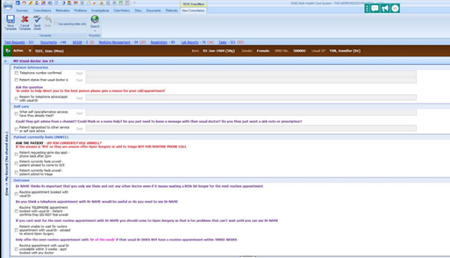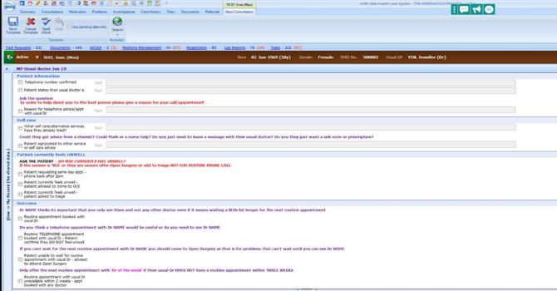

Keep learning
It will get easier with time and experience.
You learn the conversations and you learn which patients are most likely to challenge and you learn how to respond.
Use your regular Reception Team Meetings as an opportunity for:
- Sharing any concerns
- Confirming how to respond to patient needs or requests
- Reviewing how patients are redirected
- Update staff training
- Sharing experiences to build learning

With thanks to all those who contributed and particular thanks to the Reception Team at
The Merrywood Practice

Current and Future Navigation/Information
Reception Teams having updated the Usual GP field or flagged patient cohorts the table below generates thinking about changes to process to maintain/encourage continuity.
Consider the areas in which patients and patients information is navigated to GPs and if the Usual GP/Continuity of care flag could be relied upon to support this navigation/how buddies and micro-teams could support. Other uses: Summarise current process map and future process map changes; to list and prioritise changes that will be tested via PDSA cycles.
Process | Current Navigation | Future/Proposed Navigation
New patient registrations
Routine appointment or triage requests
Urgent appointments
Urgent appointments if fully booked
Late appointments squeezed in
Test results
Test results when Usual GP not in
Repeat prescriptions
Urgent prescription requests
Electronic documents (workflow)
Safeguarding
Death administration

Patients Informed of | Currently Informed By | Future/Proposed Informed By
Who their Usual GP is
Knowing Usual GP work pattern

