Using EMIS to support continuity

Practices may wish to consider how they can use the clinical system to support them in improving continuity of care.

Here we share mechanisms used by Bristol practices. All Bristol practices use EMIS but it is assumed similar mechanisms are available in the other clinical systems.

Contents

Tagging continuity of care patients 2

Setting up a protocol 2

Setting an alert 3

Adding a session filter 3

Alerts on care plans 4

Using a micro-team template 4

Restricting online patient booking 5

Using EMIS prompts 5

Who did the patient see? 6

# Tagging continuity of care patients

Practices may like to add a code to identify either:

* those patients for whom the Usual GP field is now correct.
* the cohort of patients for whom continuity is being improved.

The continuity of care codes:

* EMIS Code is EMISCCO16
* SNOMED Code is 980781000006105

# Setting up a protocol

The flow chart below sets out how to set up a protocol for one patient or multiple.

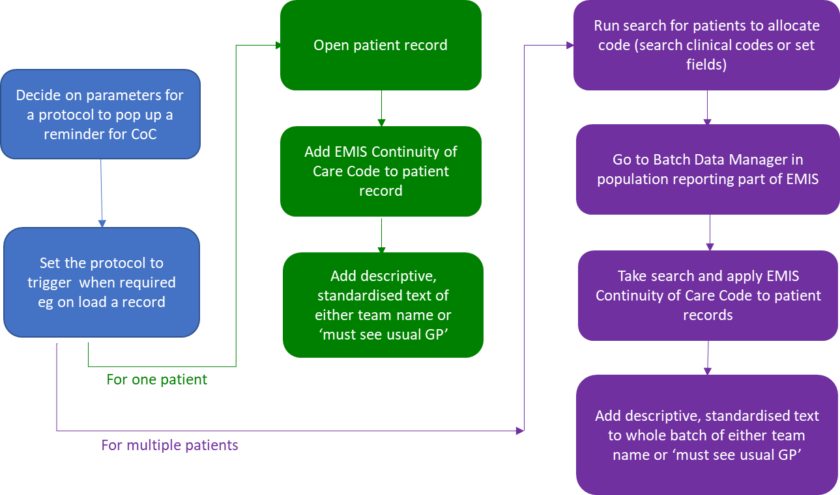

Note: if there is joint responsibility then the trigger for the protocol needs to be on ‘load the record’.

# Setting an alert

To maintain an up-to-date Usual GP Field, use an alert to remind colleagues to check the patient’s usual doctor.

An alert is useful where the practice is looking to improve continuity for a group or cohort of patients, e.g., frailty patients, those on the mental health register or palliative care patients.

If you date the alert it enables you to see when a patient changed GPs and flag any patients making frequent changes to the Practice Manager. Practices have found it useful to have the process of responding to changes to GP managed by one or two people, e.g. the Practice Manager and Reception Manager.

Screenshot showing the setting of an alert.

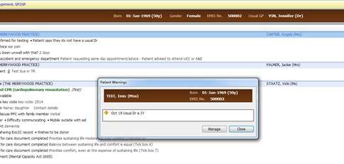

# Adding a session filter

The flow diagram below is an overview of setting a session filter to enable appointments to be searched by micro-team.

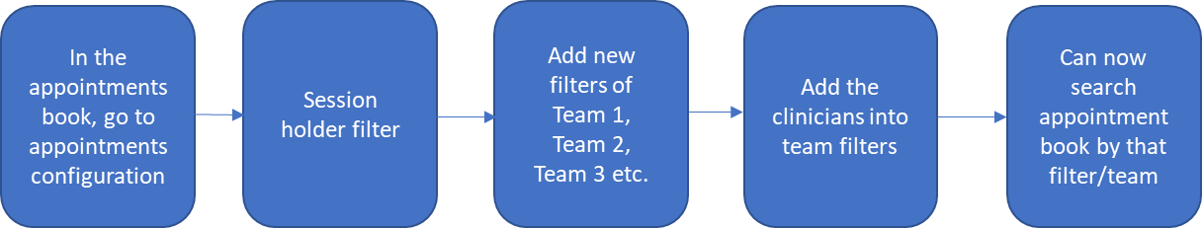

# Alerts on care plans

This is used in SDM (Shared Decision Making) and in Alerting Reception.

In the Care Plan, the agreement on patient care between the GP and the Patient is noted.

Using the Care Plan, the GP can alert the Reception Team to what has been agreed with the patient. This may be useful, for example, in managing frequently attending patients.

Below an example of process mapping the requirement

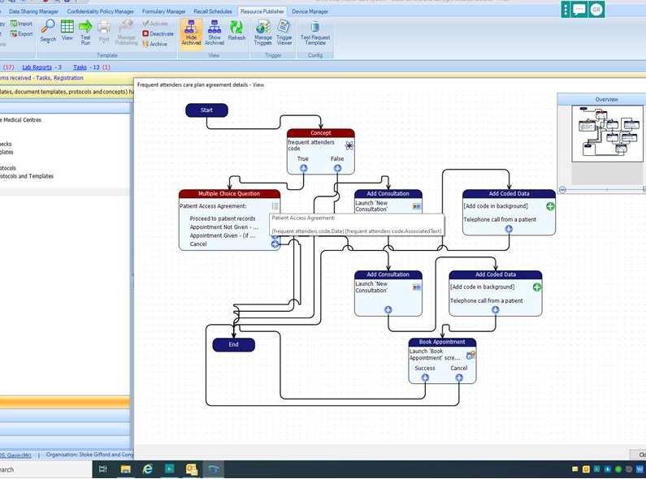

# Using a micro-team template

The Valentine Continuity of Care Project used EMIS templates to facilitate the sharing of key information about patients between members of the micro-team. Please refer to the [Valentine Report](https://www.health.org.uk/sites/default/files/2021-02/valentine_continuity_report_final.pdf) for more information.

# Restricting online patient booking

Patient online booking access can be restricted, and this will support continuity of care by ensuring patients book with their Usual GP.

For ‘patient facing services booking’ the practice selects ‘own patients.

At first, patients will be offered or prompted to book their own GP. If there are no available appointments, they can book any other GP.

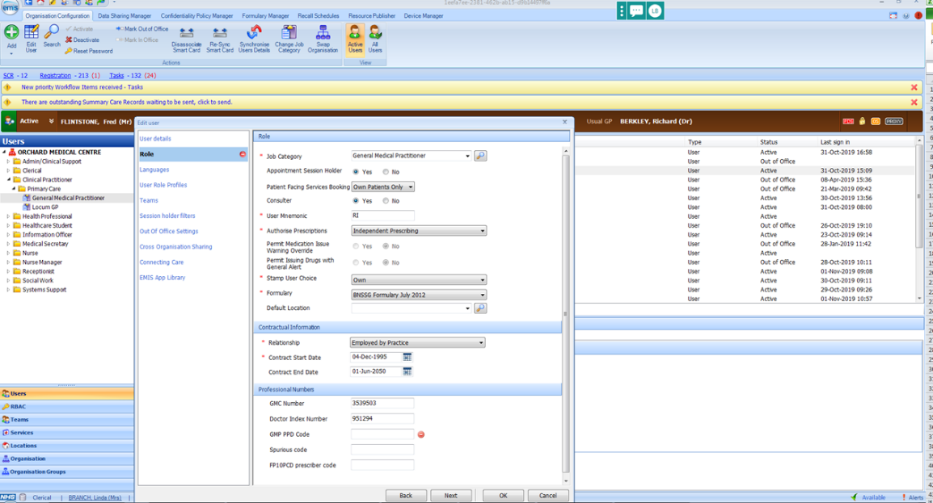

# Using EMIS prompts

Prompts can support the team to improve continuity. Examples used by one practice are shared in the screenshots below (purple text) and include:

* a reminder to let the patient know the GPs at the practice think seeing the same GP is important, even if it means waiting.
* a reminder to offer the patient a Dr of the week appointment only if their own GP does not have a routine appointment available within the next 3 weeks.

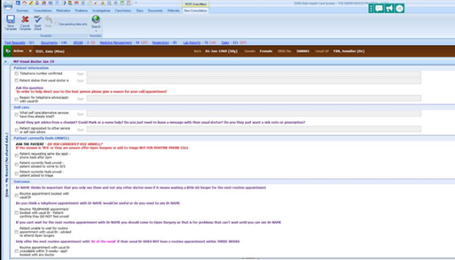

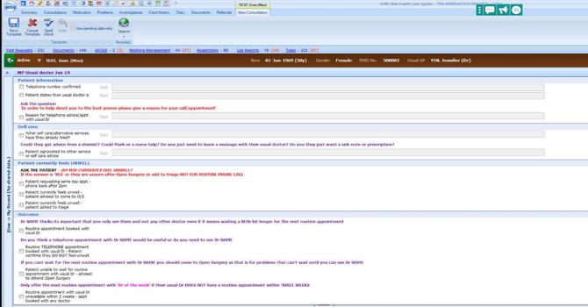

# Who did the patient see?

Search on all appointments for a certain time and run a report showing who was patient’s usual GP on EMIS compared to who the patient saw.

The search is included at the end of the step-by-step guidance.

1. Select ALL consultations in a specified time slot with the users you want to review.



1. Run the associated report making sure you select ‘Fill patient Details’.

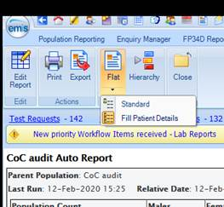

1. Export the report to Excel.
2. Open the Excel document – this is where it gets clunky!
3. Select all the data and use the Find & Select function in Excel to replace all empty cells with an ‘x’.

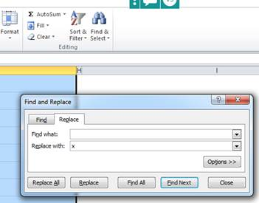

1. Select all the data and use the ‘Sort and Filter’ function to select the consultations you want to review.

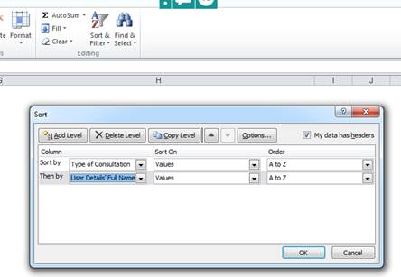

1. You can then delete all the ones you do not want – including the empty (x) ones.
2. The data should also be sorted by user as well – so get rid of the data for users that you are not interested in!
3. You should now have a list of patient number/appointment date/appointment type/clinician/usual Dr (see attached) – you might need to fill in the gaps for the usual Dr (where the x is).

Copy of EMIS search:

