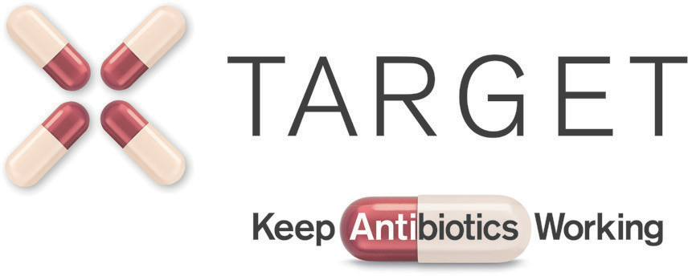
COMMUNITY PHARMACY FLOWCHART
A guide for when to use which TARGET resource for the management of Respiratory tract infection (RTIs) and Urinary tract infections (UTIs) in patients presenting in community pharmacy.

Leaflets to be used
WITH patient
Share leaflets links
with patient

Respiratory tract infection
TARGET Antibiotic checklist

Pharmacy consultation
responding to symptoms
Treating your infection RTI
Self care

Post GP consultation
prescription collection
Self care RTI pictorial

Urinary tract infection

Pharmacy consultation
responding to symptoms

Post GP consultation
prescription collection
Treating your infection UTI
UTI pictorial

UTI pictorial
TARGET Antibiotic checklist

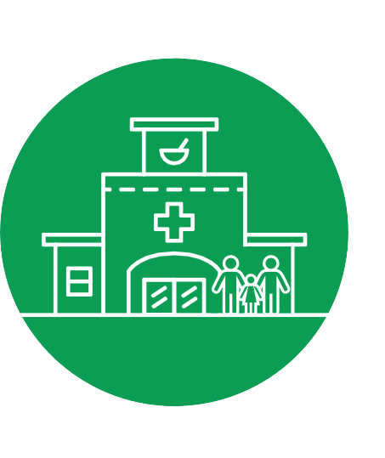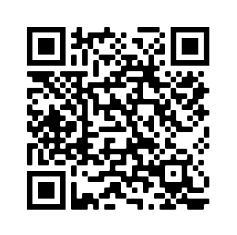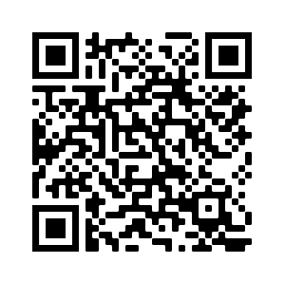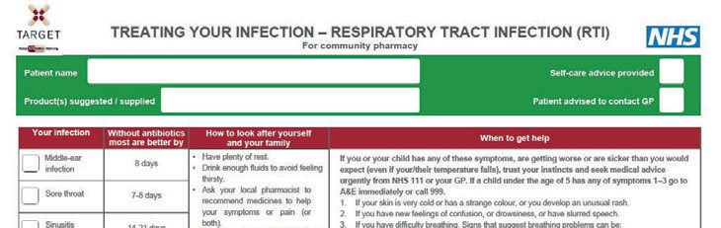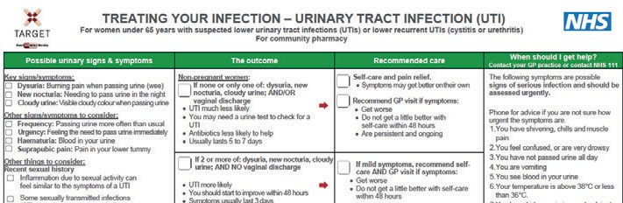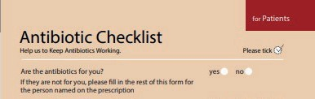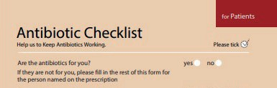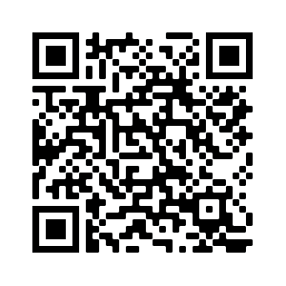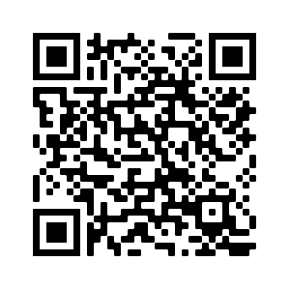

All TARGET resources for the community pharmacy setting can be found here:
www.rcgp.org.uk/target-pharmacy

TARGET is operated by the UK Health Security Agency. Developed in collaboration with professional medical bodies. Published November 2022, Review: November 2025. Version 1. KAW18-07 © Crown copyright 2018.

