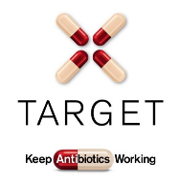
TARGET Treating Your Infection

Respiratory Tract Infection (RTI) Pharmacy Leaflet

User Guide

Summary
Patient leaflets outlining the natural history of respiratory tract infections can result in reduced antibiotic prescribing. The TARGET Treating Your Infection - Respiratory Tract Infection Pharmacy (TYI-RTI) Leaflet was developed as a tool to share with patients in the pharmacy to educate them about using antibiotics responsibly.

What are the aims of the Treating Your Infection (RTI) leaflet?
The leaflet aims to give information, in line with NICE guidance (NG15 and NG63) on:
- The natural course of self-limiting infections
- How people can self-care
- Explicit advice on when to seek medical help
- Appropriate antibiotic use and the side effects of antibiotic

Overview of the leaflet
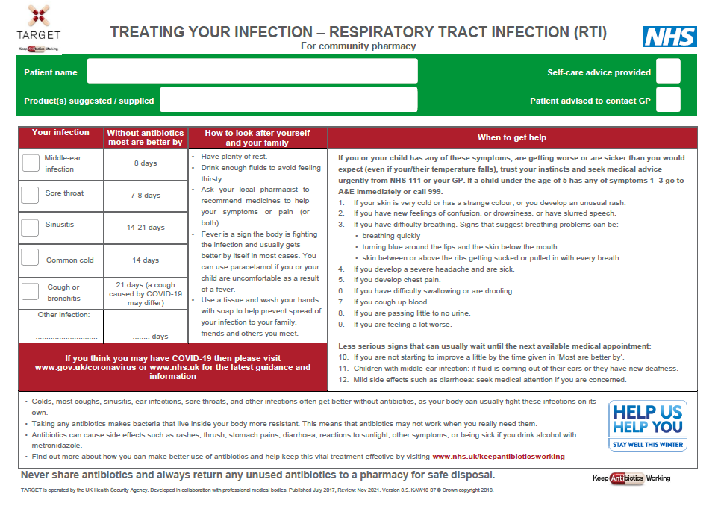
Patient details and Care Decision
To be completed by pharmacy staff in order to personalise the leaflet for each patient.
Why Did You Not Get Antibiotics Today?
Central section
Use this section to provide a simple explanation of why antibiotics may not be needed. The table provides tick boxes to use to explain to the patient what illness they are currently suffering from, how long their illness is likely to last (based on NICE evidence). The other section at the bottom table can be used to note any illnesses that are not included within the table. The “How to look after yourself
and your family” and “When should you get help?” section should be explained to the patient.
Why Should You Only Take Antibiotics When They Are Needed?
Provides information to patients regarding the importance of appropriate and responsible antibiotic use. This can be explained in a discussion with the patient or referred to for the patient to read in their own time.
COVID-19 Information
Information about guidance for patient if they think they might have COVID-19

To use this leaflet properly, it is important that it is used as a tool to interact with patients, rather than as a ‘parting gift’. In order to do this effectively you should be familiar with its content.

Why create the Treating Your Infection (RTI) leaflet?
Prescribers often feel caught between not prescribing antibiotics and expectations from patients to prescribe. However, there is evidence that prescribers often overestimate patients’ expectations for antibiotics, and that many patients, when they are fully informed about the modest benefits and potential harms from treatment, would rather not receive antibiotics. 70-80% of all antibiotics are prescribed in the community, therefore sharing leaflets with patients presenting with RTIs significantly reduces inappropriate use of antibiotics.

NICE endorsement

The TARGET TYI-RTI leaflet specifically relates to the following NICE guidelines:
- NG15 Antimicrobial stewardship: systems and processes for effective antimicrobial medicine use: 1.1.31, 1.1.33, 1.1.34
- NG63 Antimicrobial stewardship: changing risk-related behaviours in the general population: 1.3.2,1.5.5 and 1.5.6

We are happy to receive feedback about how you have used this leaflet and any constructive comments on how it can be improved. Please contact us at TARGETantibiotics@ukhsa.gov.uk.

