

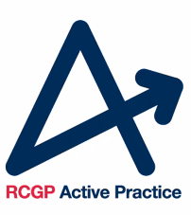

Active Practice Charter Evaluation Form

Form 2: staff questionnaire

For the following statements, please indicate your level of agreement:

- Being an Active Practice has led to me increasing my personal physical activity levels
□ Strongly agree
□ Agree
□ Neither agree nor disagree
□ Disagree
□ Strongly disagree

- Being an Active Practice has led to an increase in staff physical activity levels
□ Strongly agree
□ Agree
□ Neither agree nor disagree
□ Disagree
□ Strongly disagree

- Being an Active Practice has led to an increase in delivery of physical activity promotion to patients
□ Strongly agree
□ Agree
□ Neither agree nor disagree
□ Disagree
□ Strongly disagree

4. What is the recommended amount of physical activity per week for adults (19-64 years) and older adults (65+)?
Please choose only one of the following:
- 60 minutes
- 90 minutes
- 150 minutes
- 180 minutes
- 300 minutes
- Don't know
5. On a scale of 1-10 how confident are you that you regularly meet these guidelines?
Please refer to the UK Chef Medical Officers' Physical Activity Guidelines.

6. How are staff in your workplace encouraged to increase their physical activity levels? Please provide as much detail as you can.

7. How are patients encouraged to increase their physical activity levels? Please provide as much detail as you can.

